Impact of COVID-19 vaccination on the risk of SARS-CoV-2 infection and hospitalization and death in Italy
(27.12.2020 - 29.08.2021)
Combined analysis of data from the National Vaccination Registry
and the COVID-19 Integrated Surveillance System
Key Points
- The aim of this report is to estimate the risk of COVID-19 (including symptomatic and asymptomatic cases), and the risk of subsequent hospitalization, admission to an intensive care unit (ICU), and death, at different time intervals since vaccination, in individuals fully vaccinated with mRNA vaccines in Italy, both overall and separately by age group, vaccination priority group, and epidemic phase.
- This report takes into consideration over 29 million people (more than 56% of the Italian population aged ≥16 years) who received at least one dose of an mRNA COVID-19 vaccine (Comirnaty or Spikevax, received by over 80% of vaccinated individuals) by mid-August and followed-up to the 29th of August 2021. The risk of being diagnosed with COVID-19 is assessed up to seven months since the first vaccine dose, while the risk of diagnosis with subsequent hospitalization, admission to ICU, or death is assessed up to six months.
- The incidence rate ratios and vaccine effectiveness in preventing the study events at different time intervals from the second dose were estimated considering the time interval 0-14 days from the 1st dose as reference group (as a proxy of unvaccinated individuals).
- In the overall population, over the whole study period, we did not observe a reduction of the protective effect of vaccination, against symptomatic or asymptomatic COVID-19 diagnosis, after about seven months since the 2nd dose (vaccine effectiveness=89%), nor against diagnosis with subsequent hospitalization (vaccine effectiveness=96%), admission to ICU (vaccine effectiveness=96%), or death (vaccine effectiveness=99%) after about 6 months.
- In immunocompromised vaccinated individuals, a reduction of the protective effect of vaccination against any COVID-19 diagnosis was observed starting from 28 days after the 2nd dose, although estimates have large confidence intervals.
- Similarly, a reduction of the protective effect of vaccination was observed in individuals affected by comorbidities, among whom vaccine effectiveness against any COVID-19 diagnosis (symptomatic or asymptomatic) decreased from 75% at 28 days after the 2nd dose to 52% after 141-224 days.
- We also observed a slight increase in the risk of any diagnosis among individuals ≥80 years of age and nursing home residents after about 6 months from the 2nd dose; nevertheless, vaccine effectiveness remained >80% at about 7 months after the 2nd dose.
- The analysis stratified by epidemic phase showed that vaccine effectiveness in preventing any symptomatic or asymptomatic COVID-19 diagnosis in completely vaccinated persons (> 14 days since the 2nd dose) decreased from 84.8% (95% CI: 84.3-85.3%) in the period from 27/12/2020 to 13/6/2021 (characterized by predominance of the alpha variant) to 67.1% (95% CI: 65.1-69.0%) in the period from 19/7/2021 to 29/8/2021 (characterized by predominance of the delta variant).
- By contrast, vaccine effectiveness in preventing diagnosis with subsequent hospitalization remains high: 91.7%, (95% CI: 91.0-92.4%) during phase-alpha and 88.7 (95% CI: 66.1-96.3%) during phase-delta (analysis of hospitalization censored on 1/8/2021). However, these estimates lack precision and need more follow-up data for an adequate evaluation.
- The diminished effectiveness against any COVID-19 diagnosis, observed during phase-delta, may be due to waning immunity of vaccines or immune-evasion. Behavioral factors may also have contributed.
- A longer follow-up time is needed to adequately evaluate any potential reduction of the protective effect of vaccination against severe illness (i.e., hospitalization, admission to ICU, death), both overall and by vaccination priority groups, during the epidemic phase-delta.

This report was produced by the ISS Working Group and the "COVID-19 vaccine surveillance system” of the Ministry of Health
Patrizio Pezzotti, Massimo Fabiani, Antonietta Filia, Alberto Mateo Urdiales, Chiara Sacco, Fortunato (Paolo) D’Ancona, Matteo Spuri, Flavia Riccardo, Antonino Bella (DMI, ISS)
Francesca Menniti Ippolito, Roberto Da Cas, Marco Massari, Cristina Morciano, Stefania Spila Alegiani (CNRVF, ISS)
Maria Puopolo (NEURO, ISS)
Marco Tallon (DG-INF, ISS)
Serena Battilomo, Valeria Proietti (DG-SISS, Ministry of Health)

The COVID-19 Integrated Surveillance Group in ISS:
Antonino Bella, Alberto Mateo Urdiales, Martina Del Manso, Massimo Fabiani, Matteo Spuri, Chiara Sacco, Stefano Boros, Maria Cristina Rota, Antonietta Filia, Marco Bressi, Maria Fenicia Vescio, Daniele Petrone, Marco Tallon, Corrado Di Benedetto, Alessandra Ciervo, Paola Stefanelli, Flavia Riccardo, Patrizio Pezzotti

Regional Contact Persons for the COVID-19 Integrated Surveillance Group:
Antonia Petrucci (Abruzzo); Michele La Bianca (Basilicata); Anna Domenica Mignuoli (Calabria); Pietro Buono (Campania); Erika Massimiliani (Emilia-Romagna); Fabio Barbone (Friuli Venezia Giulia); Francesco Vairo (Lazio); Camilla Sticchi (Liguria); Danilo Cereda (Lombardy); Lucia Di Furia (Marche); Francesco Sforza (Molise); Annamaria Bassot (A.P. of Bolzano); Pier Paolo Benetollo (A.P. of Trento); Chiara Pasqualini (Piedmont); Lucia Bisceglia (Apulia); Maria Antonietta Palmas (Sardinia); Salvatore Scondotto (Sicily); Emanuela Balocchini (Tuscany); Anna Tosti (Umbria); Mauro Ruffier (Valle D'Aosta); Filippo Da Re (Veneto)

Regional Contact Persons for the National Vaccination Registry (AVN) (AVN flow of anti-COVID-19 vaccinations):
Camillo Odio (Abruzzo); Michele Recine (Basilicata); Innocenza Ruberto (Calabria); Salvatore Ascione e Massimo Bisogno (Campania); Gandolfo Miserendino, Massimiliano Navacchia (Emilia-Romagna); Beatrice Del Frate, Emanuela Cau (Friuli Venezia Giulia); Diego Baiocchi, Danilo Fusco (Lazio); Domenico Gallo (Liguria); Maria Rosa Marchetti (Lombardia); Liana Spazzafumo (Marche); Raffaele Malatesta (Molise); Antonio Fanolla (A.P. of Bolzano); Diego Conforti, Carlo Trentini (A.P. of Trento); Antonino Ruggeri (Piedmont); Concetta Ladalardo, Nehludoff Albano (Apulia); Marco Corona, Paolo Lombardi (Sardinia); Massimo Iacono (Sicily); Paolo Bruno Angori, Andrea Belardinelli (Tuscany); Milena Solfiti (Umbria); Stefano Fioraso (Valle D'Aosta); Chiara Poma, Nadia Raccanello (Veneto).

Introduction
As other European countries, Italy launched its COVID-19 vaccination campaign on 27 December 2020. Four vaccines are approved and licenced for use in Italy: mRNA vaccines Comirnaty (BNT162b2 mRNA, BioNTech-Pfizer, Mainz, Germany/New York, United States (US) and Spikevax (mRNA-1273, Moderna, Cambridge, US); and viral vector vaccines Vaxzevria (ChAdOx1 nCoV-19, Oxford-AstraZeneca, Cambridge, United Kingdom), and Janssen (Ad26.COV2-S (recombinant), Janssen-Cilag International NV, Beerse, Belgium). As of September 1st 2021, 72% of the Italian population aged 12 years or more had received at least one dose of vaccine, with 64% having received the full vaccination series. About 80% of vaccinated persons in Italy received the mRNA vaccine Comirnaty or Spikevax, the first authorised and utilised during the vaccination campaign.
For all vaccines, the initial randomised trials have shown a high efficacy against a primary endpoint of symptomatic COVID-19. The effectiveness of these vaccines in reducing morbidity and mortality rates from SARS-CoV-2 diagnosis has been confirmed by observational data collected since being widely distributed, in real world scenarios (1-7). Recent observational studies have also attempted to address the challenges that remain about the potential waning of vaccine-induced immunity and a possible decreased effectiveness against variants of concerns (8).
Regarding the variants of concern, Italy has been characterized by an epidemic phase with a predominance of the Alpha variant in the first six months of 2021, a transition phase from mid-June to mid-July in which Alpha and Delta variants were both largely circulating, and a subsequent phase characterised by predominance of the Delta variant (9).
This is the fourth report on the combined analysis of data from the Italian National Vaccination Registry and the national COVID-19 integrated surveillance system. This activity is pursuant to Decree-law No. 2 of 14 January 2021 regulating the information systems that are instrumental to implementing the national strategic vaccination plan for the prevention of SARS-CoV-2 infections (Art. 3, Paragraph 7).
Previous reports were exclusively based on the Alpha predominance phase and they estimated that the highest effectiveness (against risk of any Covid-19 diagnosis, hospitalization and death) occurred starting 15-30 days after second dose administration, plateauing after that and remaining quite stable up to around 5 months (7, 10).
In this study, we aim to provide, based on a longer follow-up time and a higher number of vaccinated individuals, an updated estimate of the risk of any COVID-19 diagnosis, hospitalization, including admission to an ICU, and death, in Italy, at different time intervals since vaccination, in individuals fully vaccinated with an mRNA vaccine, both overall and separately by age group, vaccination priority group, and epidemic phase.

Methods for estimating the risk of diagnosis, hospitalization, admission to an Intensive Care Unit (ICU) and death in vaccinated individuals in Italy
The national integrated COVID-19 surveillance system in Italy collects data on individual cases of confirmed COVID-19 defined as any person with a laboratory-confirmed human SARS-CoV-2 infection, whether symptomatic or asymptomatic (11). Following diagnosis, cases are followed and any COVID-related hospitalization, admission to ICU, or death among these is reported to the surveillance system.
We retrieved, from the Italian National Vaccination Registry held by the Ministry of Health (12), data on vaccinated persons (updated up to 15/9/2021). This registry reports date and type of vaccine administration, demographic data (i.e., age, sex, region of administration), information about mutually exclusive priority groups as reported by the local health units where individuals were vaccinated (e.g., health care worker, nursing home residents, school personnel, member of armed forces, member of other essential services, presence of any chronic comorbidity) and information about immunocompromised status.
To analyse data on COVID-19 outcomes (i.e., diagnosis of SARS-CoV-2 infection with or without symptoms, COVID-19–related hospitalization, admission to ICU, death) we performed a record linkage of this data with that from the National COVID-19 Integrated Surveillance System coordinated by the Italian National Institute of Health (updated 15/9/2021).
We excluded from the analysis individuals diagnosed with SARS-CoV-2 infection prior to receiving their first vaccination dose, and those who had not been subjected to at least a two-weeks observation period (follow-up) following vaccination, to allow for development and notification of the events under study. Moreover, we excluded all individuals who received at least one dose with vaccines other than the Comirnaty and Spikevax, the first vaccines authorised and utilised during the vaccination campaign, therefore allowing for a longer observation period.
Further details about the two data sources used for this analysis can be found in previous reports/publications (7,10).

Figure 1. Timeline of the periods of selection and event ascertainment in the population under study
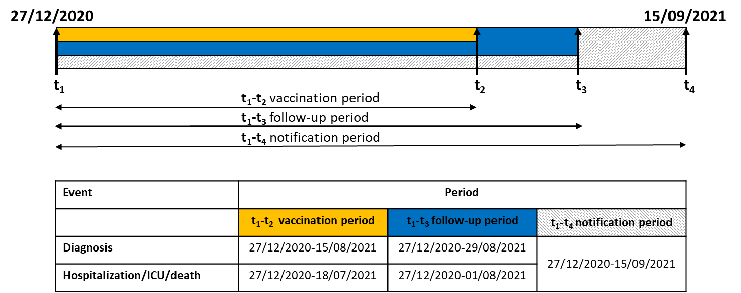

Figure 1 shows the timeline at which the study populations were selected. In particular, the rate of diagnosis of COVID-19, calculated for the period up to August 29, was estimated in individuals who had received a first dose of vaccine by August 15, to allow an adequate follow-up period of at least 14 days from vaccine administration for diagnostic assessment (including the incubation period). Record linkage was performed on data extracted on 15 September to allow time for diagnosed cases to be reported to the surveillance system.
For the same reasons, rates of diagnosis with subsequent hospitalisation, ICU admission and death were ascertained in those who had received the first of vaccine by July 18. A longer follow-up period was necessary in this case to allow an adequate time to observe possible worsening of clinical conditions up to hospitalization/death. We considered only hospitalizations, admissions to ICU, and deaths occurring within 28 days from diagnosis.

The details of the inclusion and exclusion criteria are described in Figure 2.

Figure 2. Flow chart of the study population from the National Vaccination Registry and the COVID-19 Integrated Surveillance System for assessment of the study events
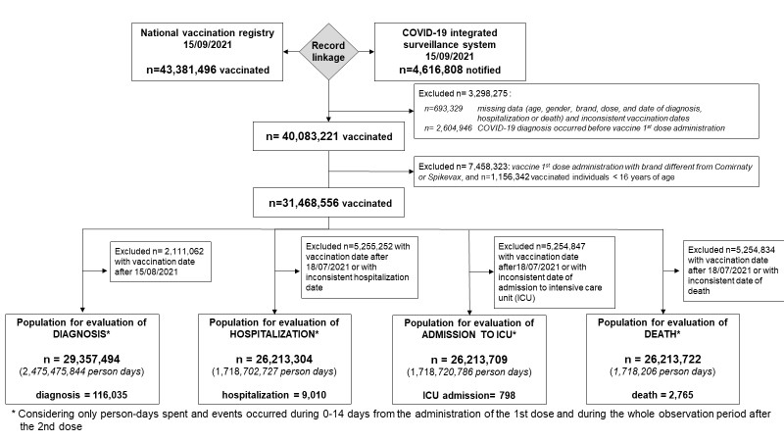

We split individual data by two-week time intervals from the first and second dose administration and fixed the censoring date at 29/8/2021 to evaluate any Covid-19 diagnosis, and at 1/8/2021 to evaluate diagnosis with subsequent hospitalisation, admission to ICU, and death. The incidence rates of any diagnosis and of diagnosis with subsequent hospitalisation, ICU admissions, and death were calculated as the ratio between the number of study events and the total observation period (person-time in days) in the time-interval 0-14 days after the first dose administration and after the second dose administration.
Of note, at in this analysis we do not have information on the vital status, not related to COVID-19 diagnosis. Thus, based on the life tables published by the Italian Institute of Statistics (Istat) for the year 2020 (13), by region, age and sex, assuming a uniform distribution of deaths over the year, we accounted for the expected date of death in vaccinated individuals who did not experience the events under study in calculating the person-days of exposure. The follow-up period ended at the date of SARS-CoV-2 diagnosis for those who experienced the study events.
Rates were also stratified by age group (<40 years, 40-59 years, 60-79 years, and ≥80 years), gender, geographical area (north, centre, and south and islands), calendar period of administration of the first vaccine dose, and vaccination priority group (healthcare workers, nursing home residents, individuals with comorbidity, immunocompromised individuals, other priority groups (e.g., school personnel, army forces)).
Multivariable analyses were then performed to estimate the reduction of risk of any diagnosis and diagnosis with subsequent hospitalisation, ICU admission and death at different time intervals after the administration of the second dose of vaccine compared to the 0–14-day time-interval after the first dose administration (reference period, proxy of the risk in the unvaccinated individuals, see reference 7 for details).
The multivariable analyses were carried out through negative binomial regression model with a robust variance estimator, including the following covariates: gender, age group, region of vaccination, vaccine brand (Comirnaty/Spikevax), vaccination priority group, and epidemic phase [phase-alpha, from 27/12/2020 to 13/6/2021: predominance of alpha variant (B.1.1.7); transition phase, from 14/6/2021 to 18/7/2021: transition period; and phase-delta, from 19/7/2021 to 29/8/2021 (diagnosis) or 1/8/2021 (diagnosis with subsequent hospitalisation, admission to ICU, and death): predominance of delta variant (B.1.617.2)] (9). The analyses were also adjusted for calendar week of the first dose administration and for regional weekly incidence in the general population.
For each of the study events (any diagnosis and diagnosis with subsequent hospitalisation, ICU admission, and death), the impact of vaccination at two-week time intervals from administration of the second vaccine dose was measured as the incidence rate ratio (IRR) with 95% confidence intervals (95% CI), using the incidence rate in the in the first two weeks after the first dose administration as reference. The analysis of risk reduction of any diagnosis at different time intervals after the administration of the second dose of vaccine was also stratified by vaccination priority group, age group, and epidemic phase.

Vaccination coverage and risk of COVID-19 diagnosis and of diagnosis with subsequent hospitalization, ICU admission and death at different time-intervals from vaccine administration in Italy
At the extraction date (15/9/2021), more than 43 million people had received at least one dose of the approved vaccines (around 73% of the Italian population, more than 78% of the Italian population aged 12 years or more). More than 40 million individuals were vaccinated without a previous COVID-19 diagnosis, and among them, more than 31 million people, aged 16 years old or more, were vaccinated with mRNA vaccines (Figure 2).

Figure 3. Cumulative (panel A) and relative distribution of (panel B) of first dose vaccine administration by calendar week and age-group in persons vaccinated with Comirnaty or Spikevax
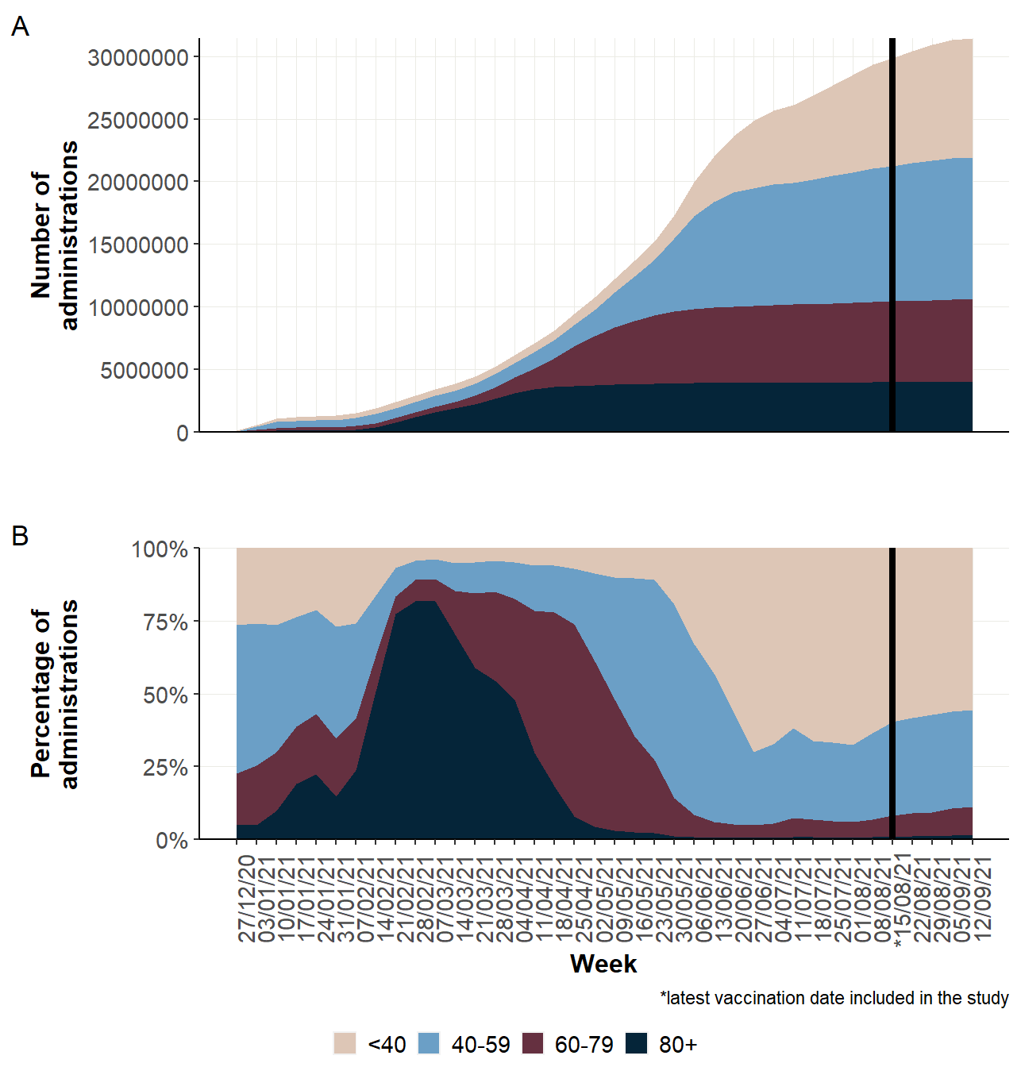
Figure 3 shows the cumulative number (panel A) and the relative distribution (panel B) of first dose administration by calendar week and age group. Of note, the age distribution by calendar week mainly reflects the priority groups, with HCW and nursing home residents being the initial groups that were vaccinated in January and February 2021, followed by individuals aged 80 years old and above (February and March) and individuals with high-risk comorbidities. Subsequently, age was the main criterion used for vaccination. Comirnaty was the most used vaccine, and about 85% of people were vaccinated with an mRNA vaccine (Figure 4).

Figure 4. Cumulative (panel A) and relative distribution of (panel B) of first dose vaccine administration by calendar week and vaccine brand in persons vaccinated with Comirnaty or Spikevax

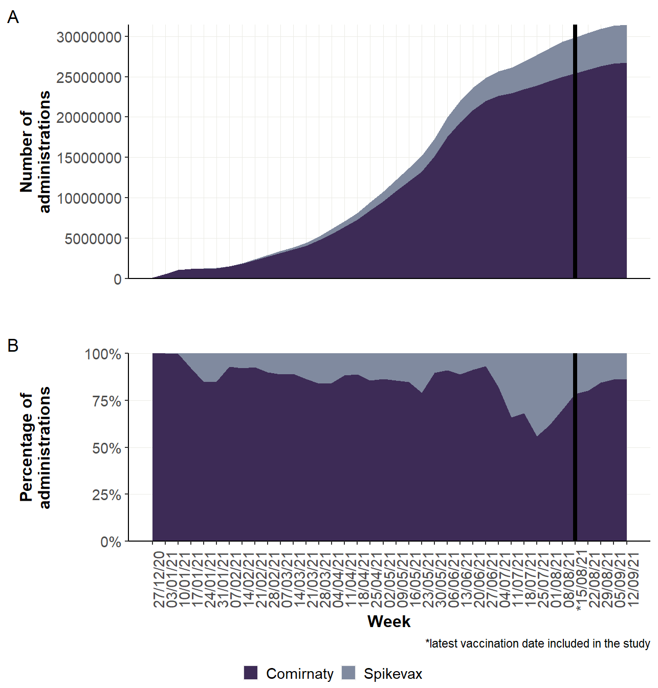
The analysis evaluating the risk of any COVID-19 diagnosis was based on 29 million people vaccinated by the 15th of August 2021; the analyses on the more severe outcomes were based on more than 26 million people vaccinated by the 18th of July, 2021. The incidence of any COVID-19 diagnosis declines from 1.13 per 10,000 person-days in the first 14 days after the first dose, to 0.34 after the second dose. A similar decrease is also observed after stratification by age, gender, geographic area, calendar period and vaccination priority group (Table 1).
Similar estimates are obtained when considering COVID-19 diagnoses with subsequent hospitalization (overall: 0.17 and 0.02 per 10,000 person-days, respectively in the first 14 days after the first dose and after the second dose, Table 2), admission to ICU (0.02 to 0.001, Table 3), or death within 28 days from diagnosis (0.05 to 0.01, Table 4), also when stratifying for the characteristics here considered. The risk reductions for Covid-19 diagnosis (any or for those with more severe outcome) were confirmed and had a larger magnitude of difference compared to the period 14 days post first dose when considering only time-periods starting 14 days since the second dose (data not shown in Table)

Table 1. Incidence rate of COVID-19 diagnosis in persons vaccinated with Comirnaty or Spikevax before 15 August 2021
 | 0-14 days from administration of 1st dose (reference) |  |  | 0+ days from administration of 2nd dose
Characteristics of persons involved in the study | Diagnoses | Person-days | Incidence  per 10,000 person-days* | Diagnoses | Person-days | Incidence  per 10,000 person-days*
Total | 46,427 | 410,704,354 | 1.13 | 69,608 | 2,064,771,490 | 0.34
Age group (years)
<40 | 14,979 | 116,564,239 | 1.29 | 17,569 | 332,241,890 | 0.53
40-59 | 11,884 | 149,027,269 | 0.80 | 24,600 | 648,180,359 | 0.38
60-79 | 8,242 | 89,962,423 | 0.92 | 12,753 | 575,428,814 | 0.22
≥80 | 11,322 | 55,150,424 | 2.05 | 14,686 | 508,920,428 | 0.29
Sex
Females | 24,755 | 213,807,852 | 1.16 | 39,389 | 1,136,179,756 | 0.35
Males | 21,672 | 196,896,502 | 1.10 | 30,219 | 928,591,734 | 0.33
Geographical area of vaccination
North | 26,914 | 217,061,647 | 1.24 | 35,125 | 1,098,117,724 | 0.32
Centre | 6,306 | 56,368,359 | 1.12 | 9,833 | 290,018,762 | 0.34
South and Islands | 13,207 | 137,274,348 | 0.96 | 24,650 | 676,635,005 | 0.36
Period of first immunisation with a COVID-19 vaccine
27/12/2020-31/01/2021 | 9,526 | 17,158,746 | 5.55 | 18,376 | 249,352,024 | 0.74
01/02/2021-28/02/2021 | 3,928 | 16,528,682 | 2.38 | 7,961 | 194,401,627 | 0.41
01/03/2021-28/03/2021 | 6,431 | 28,679,483 | 2.24 | 7,830 | 287,410,508 | 0.27
29/03/2021-25/04/2021 | 7,239 | 52,648,132 | 1.37 | 9,424 | 421,111,941 | 0.22
26/04/2021-23/05/2021 | 4,529 | 78,928,619 | 0.57 | 9,397 | 441,386,648 | 0.21
24/05/2021-20/06/2021 | 2,163 | 116,517,465 | 0.19 | 13,005 | 378,117,736 | 0.34
21/06/2021-18/07/2021 | 4,014 | 56,286,348 | 0.71 | 3,543 | 90,575,428 | 0.39
19/07/2021-15/08/2021 | 8,597 | 43,956,880 | 1.96 | 72 | 2,415,578 | 0.30
Vaccination priority group
Health care workers | 7,883 | 20,749,659 | 3.80 | 16,502 | 264,476,435 | 0.62
Nursing home residents | 3,399 | 3,950,760 | 8.60 | 4,097 | 44,083,837 | 0.93
Persons with comorbidities | 5,341 | 56,735,741 | 0.94 | 9,580 | 349,536,920 | 0.27
Immunocompromised persons | 105 | 1,009,136 | 1.04 | 149 | 6,137,758 | 0.24
Other priority groups | 3,958 | 37,520,376 | 1.05 | 8,863 | 228,587,233 | 0.39
No/not specified priority groups | 25,741 | 290,738,682 | 0.89 | 30,417 | 1,171,949,308 | 0.26
*Incidence=Number of COVID-19 diagnosis/person-days

Table 2. Incidence rate of COVID-19 diagnosis with subsequent hospitalisation in persons vaccinated with Comirnaty or Spikevax before 18 July 2021
 | 0-14 days from administration of 1st dose (reference) |  |  | 0+ days from administration of 2nd dose
Characteristics of persons involved in the study | Hospitalizations | Person-days | Incidence  per 10,000 person-days* | Hospitalizations | Person-days | Incidence  per 10,000 person-days*
Total | 6,117 | 366,742,232 | 0.17 | 2,893 | 1,351,960,496 | 0.02
Age group (years)
<40 | 168 | 87,579,371 | 0.02 | 76 | 164,510,496 | 0.005
40-59 | 602 | 136,907,984 | 0.04 | 245 | 376,774,565 | 0.01
60-79 | 1,656 | 87,414,832 | 0.19 | 544 | 405,128,037 | 0.01
≥80 | 3,691 | 54,840,046 | 0.67 | 2,028 | 405,547,398 | 0.05
Sex
Females | 2,836 | 193,556,274 | 0.15 | 1,446 | 759,977,311 | 0.02
Males | 3,281 | 173,185,958 | 0.19 | 1,447 | 591,983,185 | 0.02
Geographical area of vaccination
North | 4,137 | 193,857,446 | 0.21 | 1,849 | 722,852,438 | 0.03
Centre | 685 | 50,246,151 | 0.14 | 435 | 188,770,728 | 0.02
South and Islands | 1,295 | 122,638,635 | 0.11 | 609 | 440,337,330 | 0.01
Period of first immunisation with a COVID-19 vaccine
27/12/2020-31/01/2021 | 717 | 17,157,128 | 0.42 | 535 | 216,186,929 | 0.02
01/02/2021-28/02/2021 | 739 | 16,527,867 | 0.45 | 547 | 162,661,309 | 0.03
01/03/2021-28/03/2021 | 1,909 | 28,678,133 | 0.67 | 951 | 232,490,262 | 0.04
29/03/2021-25/04/2021 | 1,791 | 52,647,018 | 0.34 | 676 | 319,792,789 | 0.02
26/04/2021-23/05/2021 | 664 | 78,928,377 | 0.08 | 146 | 287,669,387 | 0.01
24/05/2021-20/06/2021 | 177 | 116,517,372 | 0.02 | 38 | 132,030,379 | 0.003
21/06/2021-18/07/2021 | 120 | 56,286,337 | 0.02 | 0 | 1,129,442 | 0
Vaccination priority group
Health care workers | 285 | 20,670,464 | 0.14 | 190 | 224,153,517 | 0.01
Nursing home residents | 646 | 3,933,569 | 1.64 | 409 | 36,998,294 | 0.11
Persons with comorbidities | 993 | 55,992,567 | 0.18 | 392 | 241,033,074 | 0.02
Immunocompromised persons | 20 | 988,191 | 0.20 | 8 | 4,206,478 | 0.02
Other priority groups | 208 | 35,458,799 | 0.06 | 130 | 159,423,086 | 0.01
No/not specified priority groups | 3,965 | 249,698,642 | 0.16 | 1,764 | 686,146,048 | 0.03
*Incidence=Number of COVID-19 diagnosis with subsequent hospitalization/person-days

Table 3. Incidence rate of COVID-19 diagnosis with subsequent admission to an ICU, in persons vaccinated with Comirnaty or Spikevax before 18 July 2021
 | 0-14 days from administration of 1st dose (reference) |  |  | 0+ days from administration of 2nd dose
Characteristics of persons involved in the study | ICU admission | Person-days | Incidence  per 10,000 person-days* | ICU admission | Person-days | Incidence  per 10,000 person-days*
Total | 623 | 366,747,289 | 0.02 | 175 | 1,351,973,498 | 0.001
Age group (years)
<40 | 2 | 87,579,819 | 0.0002 | 1 | 164,512,648 | 0.0001
40-59 | 57 | 136,908,864 | 0.004 | 17 | 376,776,835 | 0.0005
60-79 | 260 | 87,415,706 | 0.03 | 53 | 405,130,670 | 0.001
≥80 | 304 | 54,842,900 | 0.06 | 104 | 405,553,345 | 0.003
Sex
Females | 208 | 193,559,149 | 0.01 | 67 | 759,985,545 | 0.001
Males | 415 | 173,188,140 | 0.02 | 108 | 591,987,952 | 0.002
Geographical area of vaccination
North | 421 | 193,861,007 | 0.02 | 90 | 722,861,306 | 0.001
Centre | 72 | 50,247,221 | 0.01 | 32 | 188,773,973 | 0.002
South and Islands | 130 | 12,263,906 | 0.11 | 53 | 440,338,219 | 0.001
Period of first immunisation with a COVID-19 vaccine
27/12/2020-31/01/2021 | 55 | 17,158,658 | 0.03 | 25 | 216,192,456 | 0.001
01/02/2021-28/02/2021 | 90 | 16,528,654 | 0.05 | 32 | 162,662,956 | 0.002
01/03/2021-28/03/2021 | 215 | 28,679,441 | 0.07 | 53 | 232,492,550 | 0.002
29/03/2021-25/04/2021 | 160 | 52,648,104 | 0.03 | 50 | 319,795,673 | 0.002
26/04/2021-23/05/2021 | 83 | 78,928,619 | 0.01 | 13 | 287,669,919 | 0.0005
24/05/2021-20/06/2021 | 12 | 116,517,465 | 0.001 | 2 | 132,030,503 | 0.0002
21/06/2021-18/07/2021 | 8 | 56,286,348 | 0.001 | 0 | 1,129,442 | 0
Vaccination priority group
Health care workers | 28 | 20,671,507 | 0.01 | 11 | 224,157,369 | 0.0005
Nursing home residents | 52 | 3,934,346 | 0.13 | 17 | 37,000,007 | 0.005
Persons with comorbidities | 134 | 55,993,162 | 0.02 | 44 | 241,034,541 | 0.002
Immunocompromised persons | 2 | 988,205 | 0.02 | 3 | 4,206,534 | 0.01
Other priority groups | 25 | 35,459,067 | 0.01 | 9 | 159,424,225 | 0.001
No/not specified priority groups | 382 | 249,701,002 | 0.02 | 91 | 686,150,823 | 0.001
*Incidence=Number of COVID-19 diagnosis with subsequent admission to ICU/person-days

Table 4. Incidence rate of COVID-19 diagnosis with subsequent death in persons vaccinated with Comirnaty or Spikevax before 18 July 2021
 | 0-14 days from administration of 1st dose (reference) |  |  | 0+ days from administration of 2nd dose
Characteristics of persons involved in the study | Deaths | Person-days | Incidence  per 10,000 person-days* | Deaths | Person-days | Incidence  per 10,000 person-days*
Total | 1,979 | 366,747,458 | 0.05 | 786 | 1,351,973,749 | 0.01
Age group (years)
<40 | 1 | 87,579,819 | 0.0001 | 2 | 164,512,648 | 0.0001
40-59 | 24 | 136,908,884 | 0.002 | 19 | 376,776,839 | 0.001
60-79 | 336 | 87,415,743 | 0.04 | 78 | 405,130,755 | 0.002
≥80 | 1,618 | 54,843,013 | 0.30 | 687 | 405,553,507 | 0.02
Sex
Females | 905 | 193,559,247 | 0.05 | 363 | 759,985,640 | 0.00
Males | 1,074 | 173,188,211 | 0.06 | 423 | 591,988,109 | 0.01
Geographical area of vaccination
North | 1,325 | 193,861,162 | 0.07 | 493 | 722,861,472 | 0.01
Centre | 212 | 50,247,221 | 0.04 | 118 | 188,773,973 | 0.01
South and Islands | 442 | 122,639,075 | 0.04 | 175 | 440,338,304 | 0.004
Period of first immunisation with a COVID-19 vaccine
27/12/2020-31/01/2021 | 450 | 17,158,732 | 0.26 | 192 | 216,192,562 | 0.01
01/02/2021-28/02/2021 | 281 | 16,528,679 | 0.17 | 178 | 162,663,015 | 0.01
01/03/2021-28/03/2021 | 653 | 28,679,483 | 0.23 | 260 | 232,492,551 | 0.01
29/03/2021-25/04/2021 | 490 | 52,648,132 | 0.09 | 142 | 319,795,758 | 0.004
26/04/2021-23/05/2021 | 86 | 78,928,619 | 0.01 | 11 | 287,669,919 | 0.0004
24/05/2021-20/06/2021 | 14 | 116,517,465 | 0.001 | 3 | 132,030,503 | 0.0002
21/06/2021-18/07/2021 | 5 | 56,286,348 | 0.001 | 0 | 1,129,441 | 0
Vaccination priority group
Health care workers | 12 | 20,671,527 | 0.01 | 10 | 224,157,373 | 0.0004
Nursing home residents | 522 | 3,934,425 | 1.33 | 212 | 37,000,156 | 0.06
Persons with comorbidities | 211 | 55,993,176 | 0.04 | 64 | 241,034,626 | 0.003
Immunocompromised persons | 1 | 988,205 | 0.01 | 2 | 4,206,534 | 0.005
Other priority groups | 28 | 35,459,067 | 0.01 | 14 | 159,424,225 | 0.001
No/not specified priority groups | 1,205 | 249,701,058 | 0.05 | 484 | 686,150,836 | 0.01
*Incidence=Number of COVID-19 diagnosis with subsequent death/person-days

Figure 5 shows the estimates, obtained from multivariable negative binomial regression model, of the adjusted Incidence Rate Ratios (IRRs) of any COVID-19 diagnosis and diagnosis with subsequent hospitalization, admission to ICU and death following the 2nd vaccine dose compared to the time interval 0-14 days after the first dose.
In the overall study population, over the whole observation period, the adjusted estimates of the IRRs of COVID-19 diagnosis and diagnosis with subsequent hospitalisation, ICU admission and death decreased rapidly starting 14 days from the first dose, plateauing after 15-28 days from the 2nd dose and reaching a vaccine effectiveness (VE) of 89% against diagnosis at around seven months after the second dose. Effectiveness against admission to either a regular hospital ward or ICU, at around six months was 96% while against death it reached 99% (Figure 1).

Figure 5. Adjusted Incidence rate ratio (IRR) of any diagnosis and diagnosis with subsequent hospitalisation, admission to ICU and death at different time intervals after the 2nd dose administration in the overall population vaccinated with Comirnaty or Spikevax (reference: 0-14 days after 1st dose administration).
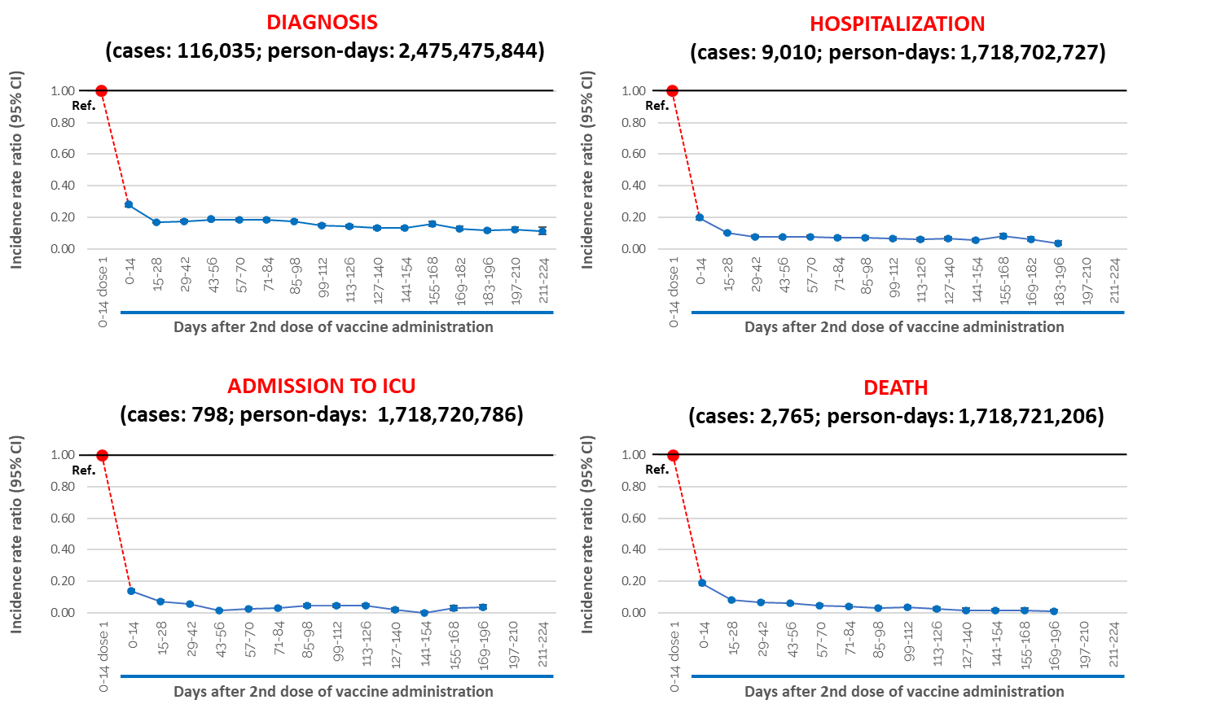

A similar pattern was observed for the risk of any COVID-19 diagnosis in the stratified analyses by age group, with IRRs reaching similar values of around 0.10 at 7 months after the second dose, in all age groups younger than 80 years of age (Figure 6). A slight increase of the IRR is observed among persons aged 80 and above starting 197 days after the second dose and reaching 0.16, thereafter maintaining an effectiveness of 84% at 211-224 days.

Figure 6. Adjusted Incidence Rate ratio (IRR) of any Covid-19 diagnosis after the 2nd dose (reference: 0-14 days after 1st dose of Comirnaty or Spikevax), by age group

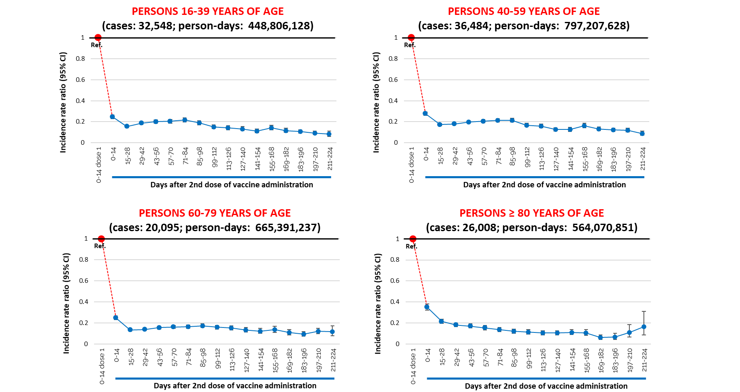

Figures 7 shows the estimates of IRRs of SARS-CoV-2 diagnosis in priority group subpopulations. Among health care workers, the IRRs decreased substantially after the second dose, compared to the time-interval 0-14 days after the 1st dose, reaching the value of 0.06 at 211-224 days.

Figure 7. Adjusted Incidence Rate ratio (IRR) of any Covid-19 diagnosis after the 2nd dose (reference: 0-14 days after 1st dose of Comirnaty or Spikevax), by mutually exclusive priority group subpopulation.
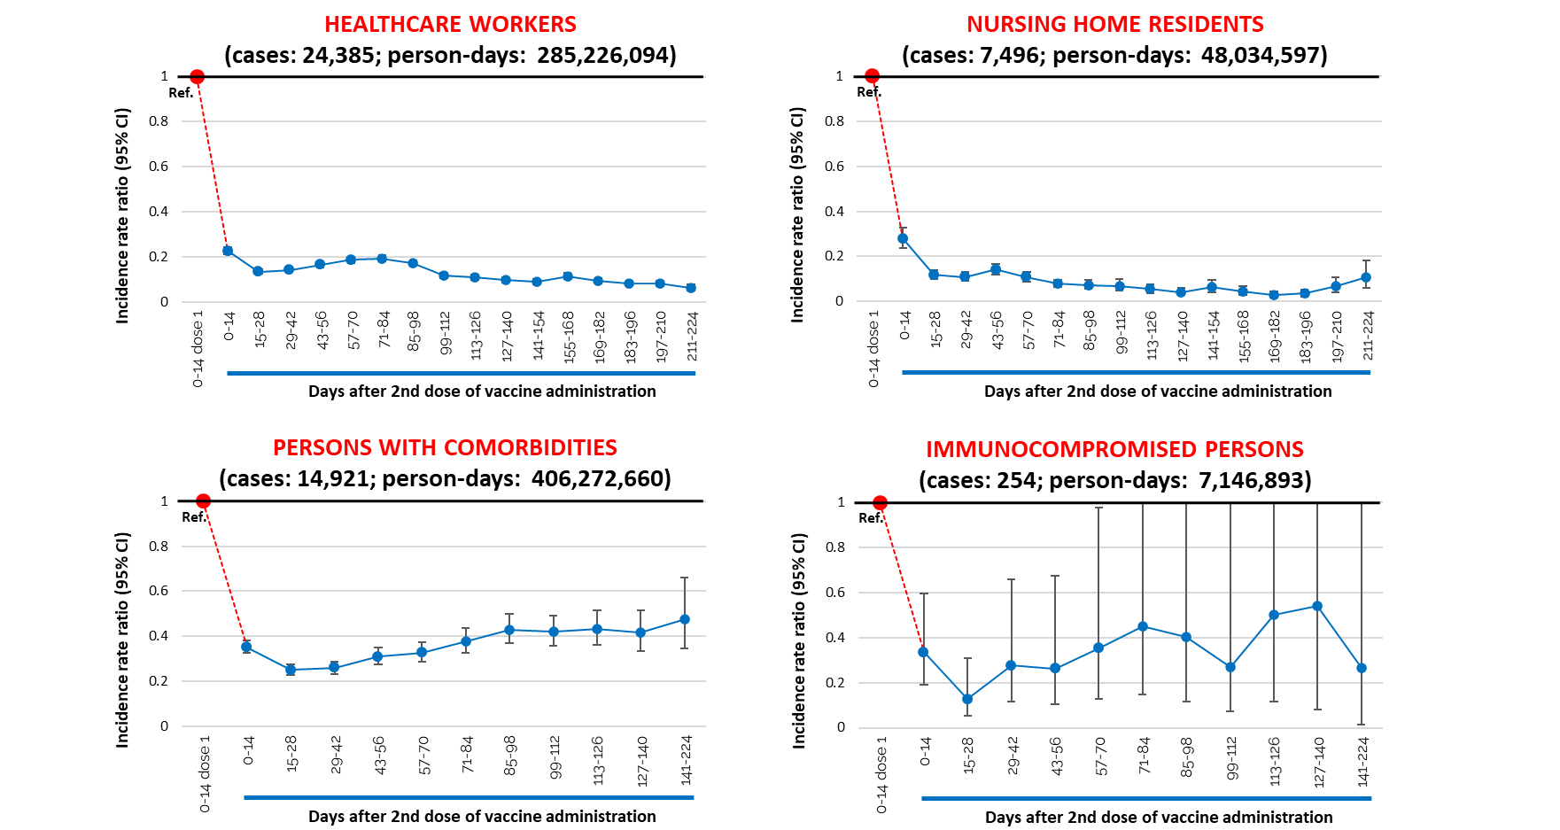

Among nursing home residents, the IRR of any COVID-19 diagnosis showed a rapid decline after the second dose until 15-28 days from its administration. After this time, it remained substantially stable (at about 0.15), although slightly increasing after approximately six months from the 2nd dose. Among persons with comorbidities and immunocompromised persons, after an initial decline of the IRR until 15-28 days from the 2nd dose, we observed a trend of increase, with IRR reaching a value of 0.48 in persons with comorbidities after 141-224 days from the 2nd dose. It is worthwhile to note that estimates for time intervals more ahead from vaccination among people affected by comorbidities and, more evidently, among immunocompromised individuals have a lower precision, as shown by the wider confidence intervals. This is due to the relatively small number of people included in these risk groups and exposed in the last time intervals.

The analyses of vaccine effectiveness in preventing any COVID-19 diagnosis by epidemic phase show a different profile between Phase-alpha, when the alpha variant was predominant (period from 27/12/2020 to 13/06/2021), and Phase-delta, characterised by predominance of the delta variant (period from 19/07/2021 to 29/08/2021) (Figure 8). In phase-alpha we observed a constant decrease in IRR starting from 14 days after the second dose administration, conversely in phase-delta we observed an increase in the IRR of SARS-CoV-2 diagnosis starting from 29-42 days after the administration of the second dose, as expected because of the known increased transmissibility of the delta variant. At the time of the analysis, it was not possible to estimate the IRR for diagnosis with subsequent hospitalisation, ICU admission and death during phase-delta due to the short observation period, especially for the reference group (this analysis is censored on 1/8/2021 and considers only individuals vaccinated before 19/7/2021).

Figure 8. Adjusted Incidence rate ratio (IRR) of any COVID-19 diagnosis (symptomatic and asymptomatic) after the 2nd vaccine dose, by epidemic phase (reference: 0-14 days after 1st dose administration; vaccinated with Comirnaty or Spikevax).
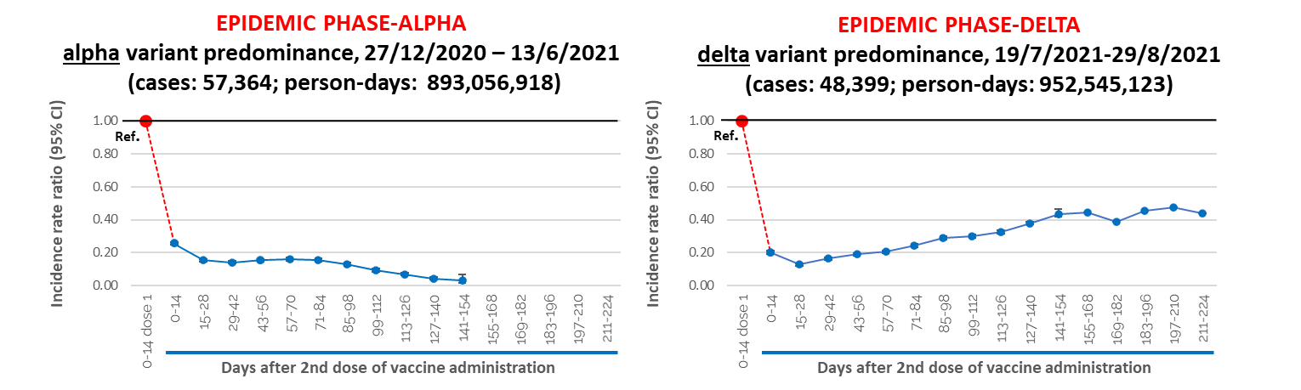

Analogous analyses as those of Figure 8, based on COVID-19 diagnoses followed by hospitalization/ICU admission/death are not presented here because, as shown in figure 1, there was not substantially sufficient follow-up time with current data and this will be evaluated in the next report.

Vaccine effectiveness in preventing any COVID-19 diagnosis in completely vaccinated individuals (vaccinated with the 2nd dose since more than 14 days) decreased from 85% during phase-alpha to 67% during phase-delta (Figure 9). Conversely, although the estimates lack precision, preliminary analyses of vaccine effectiveness in preventing COVID 19 diagnosis with subsequent hospitalization suggest that the effectiveness remains high during phase delta (VE=89% during phase-delta compared to 92% during phase-alpha).

Figure 9. Adjusted vaccine effectiveness in preventing any COVID-19 diagnosis (symptomatic and asymptomatic) and diagnosis with subsequent hospitalization after complete vaccination (> 14 days from 2nd dose administration), by epidemic phase (reference: 0-14 days after 1st dose administration; vaccinated with Comirnaty or Spikevax).

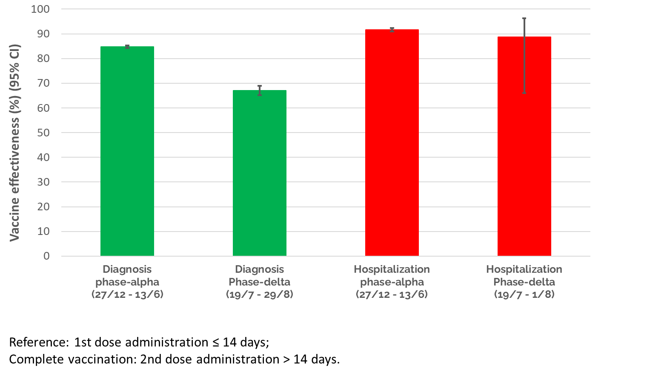

Interpretation and caveat
Our results suggest that in Italy, COVID-19 vaccination with two doses of mRNA vaccines has significantly reduced the risk of COVID-19 diagnosis and COVID-19-related hospitalisation and death, particularly starting 14 days from receipt of the second dose. In the overall study population, the risk of any COVID-19 diagnosis, hospitalisation, ICU admission and death decreased rapidly starting 14 days after the first dose, with the highest vaccine effectiveness (VE) (compared to the risk in the 14 days after the first dose which is considered equivalent to the risk in the unvaccinated population) being observed in the interval 15-28 days after the second dose and remaining quite stable in the following months. Effectiveness was 89% against any COVID-19 diagnosis about seven months after the second dose, 96% against a COVID-19 diagnosis with admission to hospital or to an ICU at about six months, and 99% against COVID-19-related death at about six months. Similar levels of VE were observed for any COVID-19 diagnosis in the stratified analyses by age group, except for the ≥80-year age group where a slight decrease was observed at about 6 months after the second dose (VE 84%). A similar trend was observed for nursing home residents. More importantly an increasing trend in the risk of any COVID-19 diagnosis was observed among immunocompromised individuals and in persons with comorbidities, starting about one month after the second dose and continuing for the study period. These results could indicate the early occurrence of waning immunity among these groups. However, there is evidence that the primary vaccination might not induce adequate protection in at least some immunocompromised individuals (14, 15). No increased risk of any COVID-19 diagnosis was observed among healthcare workers.
Vaccine effectiveness against any COVID-19 diagnosis was recently estimated, in another ISS report, using unvaccinated individuals as reference, to be 77% during the period April-September 2021 (17). In the present report, a more detailed analysis by epidemic phase seems to indicate that protection against any COVID-19 diagnosis (including symptomatic and asymptomatic infection) is somewhat lower in recent months during which the delta variant has been prevalent in Italy and a progressive relaxation of legal restrictions regarding social behaviour has taken place (67% during phase delta compared to 85% during phase alpha). These results are not unexpected considering the known increased transmissibility of the delta variant (16). However, we were unable to adequately evaluate whether there is decreased protection against more severe illness (i.e. risk of hospitalization, admission to ICU or death) during this time period as this analysis requires a longer follow-up of cases. However, preliminary analyses, although lacking precision, suggest that protection against hospitalisation remain high during phase-delta (88.7%, 95% CI: 66.1-96.3%). We will continue to monitor trends of vaccine effectiveness in the next reports.
Some limitations need to be taken into account when evaluating these results. Although we accounted for regional age and sex specific competitive risk of death due to causes other than COVID-19, it is possible that a residual bias may still be present in our estimates because of the differential mortality in some population subgroups. For example, nursing home residents are likely to be at higher risk of death for other causes compared with the general population of the same region, age and sex, thus leading to underestimate the incidence of SARS-CoV-2 infection with increasing time since vaccination, and therefore to underestimate the waning effect in this population subgroup.
Moreover, health care workers more exposed to the risk of infection (e.g. personnel working in ICU), who were probably vaccinated early on in the campaign, are likely to be tested more frequently and therefore promptly diagnosed in case of SARS-CoV-2 infection compared to others (e.g. administrative staff). As a consequence, any “waning” effect in healthcare workers could be even lower than that observed. Currently however, our results do not point to any waning of effectiveness in this population.

References
- Dagan N, Barda N, Kepten E, BNT162b2 mRNA Covid-19 Vaccine in a Nationwide Mass Vaccination Setting. N Engl J Med. 2021 Apr 15;384(15):1412-1423
- Haas EJ, Angulo FJ, McLaughlin JM, et al. Impact and effectiveness of mRNA BNT162b2 vaccine against SARS-CoV-2 infections and COVID-19 cases, hospitalisations, and deaths following a nationwide vaccination campaign in Israel: an observational study using national surveillance data. Lancet. 2021 May 15;397(10287):1819-1829
- Lopez Bernal J, Andrews N, Gower C, et al. Effectiveness of the Pfizer-BioNTech and Oxford-AstraZeneca vaccines on covid-19 related symptoms, hospital admissions, and mortality in older adults in England: test negative case-control study. BMJ. 2021;373:n1088
- Vasileiou E, Simpson CR, Shi T, et al. Interim findings from first-dose mass COVID-19 vaccination roll-out and COVID-19 hospital admissions in Scotland: a national prospective cohort study. Lancet. 2021 May 1;397(10285):1646-1657
- Thompson MG, Burgess JL, Naleway AL, et al. Prevention and Attenuation of Covid-19 with the BNT162b2 and mRNA-1273 Vaccines. N Engl J Med. 2021 Jul 22;385(4):320-329.
- Hall VJ, Foulkes S, Saei A, et al. COVID-19 vaccine coverage in health-care workers in England and effectiveness of BNT162b2 mRNA vaccine against infection (SIREN): a prospective, multicentre, cohort study. Lancet. 2021 May 8;397(10286):1725-1735.
- Mateo-Urdiales A, Spila Alegiani S, Fabiani M, et al. Risk of SARS-CoV-2 infection and subsequent hospital admission and death at different time intervals since first dose of COVID-19 vaccine administration, Italy, 27 December 2020 to mid-April 2021. Euro Surveill. 2021;26(25):pii=2100507
- Emerging Topics: Synopsis of COVID-19 Key Research Articles. Public Health Ontario. Available at: https://www.publichealthontario.ca/en/diseases-and-conditions/infectious-diseases/respiratory-diseases/novel-coronavirus/articles
- Istituto Superiore di Sanità. Prevalenza e distribuzione delle varianti di SARS-CoV-2 di interesse per la sanità pubblica in Italia. Rapporto n. 9 del 17 settembre 2021 (in Italian). Available at: https://www.iss.it/documents/20126/0/Bollettino+varianti+n.+9_17+settembre+2021.pdf/484b7aa2-2c0c-b109-4c31-087ed5c7b5af?t=1631890444760
- Istituto Superiore di Sanità. Epicentro. Impatto della vaccinazione COVID-19 sul rischio di infezione da SARS-CoV-2 e successivo ricovero e decesso in Italia. Archivio rapporti. https://www.epicentro.iss.it/vaccini/covid-19-report-valutazione-vaccinazione-archivio
- Riccardo F, Ajelli M, Andrianou X D, et al. Epidemiological characteristics of COVID-19 cases and estimates of the reproductive numbers 1 month into the epidemic, Italy, 28 January to 31 March 2020. Euro Surveill. 2020;25(49):pii=2000790
- Ministero della Salute. Anagrafe nazionale vaccini https://www.salute.gov.it/portale/vaccinazioni/dettaglioContenutiVaccinazioni.jsp?lingua=italiano&id=5067&area=vaccinazioni&menu=vuoto
- Istituto Nazionale di Statistica. I.Stat Tavole di mortalità http://dati.istat.it/Index.aspx?DataSetCode=DCIS_MORTALITA1
- Boyarsky BJ, Werbel WA, Avery RK, et al. Antibody response to 2-dose SARS-CoV-2 mRNA vaccine series in solid organ transplant recipients. JAMA 2021;325:2204-2206.
- Marion O, Del Bello A, Abravanel F, et al. Safety and immunogenicity of anti-SARS-CoV-2 messenger RNA vaccines in recipients of solid organ transplants. Ann Intern Med 2021 May 25 (Epub ahead of print).
- Delta coronavirus variant: scientists brace for impact. Nature News. https://www.nature.com/articles/d41586-021-01696-3
- Istituto Superiore di Sanità. Epicentro. Epidemia COVID-19 - Aggiornamento nazionale 29 settembre 2021. https://www.epicentro.iss.it/coronavirus/bollettino/Bollettino-sorveglianza-integrata-COVID-19_29-settembre-2021.pdf

