
National Reference Laboratory for monitoring
bacteriological and viral contamination of
bivalve molluscs

IFREMER
Rue de l’Ile d’Yeu
B.P. 21105
44311 Nantes cedex 3 - FRANCE

GENERIC PROTOCOL

Enumeration of Escherichia coli in live bivalve molluscan shellfish by the direct impedance technique using the BacTrac 4300 series analyser

INDEX

Foreword 3
2. Scope 3
3. Reference documents 3
4. Principle 4
5. Safety pecautions 4
6. Equipment 4
7. Metrological controls of the BacTrac 4300 series analyser 5
7.1 Characterisation 5
7.2 Daily follow-up 6
8. Diluent and culture medium 6
9. Performance testing of the culture medium 6
10. Procedures 6
10.1 Sample receipt 6
10.2 Sample storage 7
10.3 Sample selection 7
10.4 Sample preparation 7
10.5 Dilution and homogeneisation 8
10.6 Inoculation of the measurement cells 8
10.7 Connection and incubation of measurement cells 8
11. Calibration 8
12. Expression of results 9
12.1 Reading of the result expressed as the number of E. coli for each measurement cell 9
12.2 Calculation of the number of E. coli in the test sample 10
13. Uncertainty of test results 10
14. Appendix: Examples of impedance variation curves (M value) 11
14.1 Impedance variation indicative of the presence of E. coli 11
14.2 Impedance variation non-indicative of the presence of E. coli 12
14.3 Absence of impedance variation 13
14.4 Non-interpretable impedance variation 13

Foreword
The method set out in the present protocol is an indirect enumeration technique which has been calibrated (see section 11) against the most probable number (MPN) method described in ISO/TS 16649-3 (3). The method has been validated against the ISO/TS 16649-3 method in compliance with the technical validation protocol for quantitative methods set out in standard ISO 16140 (3). It also complies with the requirements of French standards NF V08-105 and NF V08-106 (3).

2. Scope
This protocol describes a technique for the enumeration of Escherichia coli in live bivalve molluscan shellfish (oysters Crassostrea gigas, mussels Mytilus edulis and Mytilus galloprovincialis, cockles Cerastoderma edule, clams Ruditapes decussatus and Ruditapes philippinarum, and tellins Donax trunculus) by direct measurement of the impedance variation at 44.0 °C using the BacTrac 4300 series analyser. This impedance technique provides an alternative to the ISO/TS 16649-3 MPN technique.
WARNING: Prior to use this technique for the enumeration of Escherichia coli in any other species with different general characteristics than those mentioned above (for example, gastropods, echinoderms, tunicates, …), a study is required to make sure that the results obtained by the reference and alternative methods are equivalent.

3. Reference documents
ISO 6887-1. Microbiology of food and animal feeding stuffs – Preparation of test samples, initial suspension and decimal dilutions for microbiological examination – Part 1: General rules for the preparation of the initial suspension and decimal dilutions.
ISO 6887-3. Microbiology of food and animal feeding stuffs – Preparation of test samples, initial suspension and decimal dilutions for microbiological examination – Part 3: Specific rules for the preparation of fish and fishery products.
ISO 7218. Microbiology of food and animal feeding stuffs – General requirements and guidance for microbiological examinations.
ISO/TS 11133-2. Microbiology of food and animal feeding stuffs – Guidelines on preparation and production of culture media – Part 2: Practical guidelines on performance testing of culture media.
ISO/TS 11133-2:2003/Amd.1. Microbiology of food and animal feeding stuffs – Guidelines on preparation and production of culture media – Part 2: Practical guidelines on performance testing of culture media. AMENDMENT 1: Test microorganisms for commonly used culture media.
ISO 16140:2003. Microbiology of food and animal feeding stuffs – Protocol for the validation of alternative methods.
ISO/TS 16649-3. Microbiology of food and animal feeding stuffs – Horizontal method for the enumeration of β-glucuronidase-positive Escherichia coli Part 3: Most probable number technique using 5-bromo-4-chloro-3-indolyl-β-D-glucuronide.
NF V08-105. Microbiology for food and animal feeding stuffs – Guidelines of impedancemetry for microbiological examinations.
NF V08-106. Enumeration Escherichia coli in live shellfish – Indirect technique using direct impedance measurement.
NF X 15-140. Measurement of air moisture – Climatic and thermostatic chambers – Characterisation and verification.
Enumeration of Escherichia coli in live bivalve molluscs – Calibration of the direct impedance technique using the BacTrac 4300 analyser, NRL Microbiology of Shellfish report, Ifremer, France, 2009.
Enumeration of Escherichia coli in live bivalve molluscs – EN ISO 16140 validation of the direct impedance technique using the BacTrac 4300 analyser – Methods comparison and interlaboratory collaborative studies. NRL Microbiology of Shellfish report, Ifremer, France, 2009.
Enumeration of Escherichia coli in live bivalve molluscs – Calibration of the direct impedance technique using the BacTrac 4300 analyser – Adjustment of calibration line coefficients, NRL Microbiology of Shellfish report, Ifremer, France, 2011.

4. Principle
The method set out in the present protocol is based on the principle that E. coli growing in a selective culture medium at 44 °C produce metabolically charged end-products that cause an impedance variation of the medium. This variation makes it possible to measure E. coli growth since it is proportional to the change in the number of E. coli in the culture. As the time at which growth is first detected, referred to as detection time (DT), is inversely related to the log number of E. coli in the sample, E. coli concentrations can be predicted from DT. A calibration process has been initially performed against the most probable number method described in ISO /TS 16649-3 to establish a mathematical relation experimentally between DT and the log concentration of E. coli.

5. Safety pecautions
Standard microbiology safety precautions should be applied throughout. Laboratories should perform a full risk assessment before performing this procedure. The laboratory design shall comply with safety requirements related to microorganisms classified in risk category 2.

6. Equipment
▪ Safety gloves
▪ Shucking knife, scalpel,…
▪ Sterile glass containers of appropriate dimensions and capacities
▪ Total-delivery pipettes of appropriate nominal capacity used to deliver volumes of 7.5 mL, graduated in 0.1 mL divisions
▪ Total-delivery pipettes of appropriate nominal capacity used to deliver volumes of 30 mL, graduated in 0.2 mL divisions
▪ Automatic or manual (mechanical) pipettor fitted for use with total-delivery pipettes
▪ Gas (Bunsen) burner or safety/electric Bunsen system
▪ Electric top pan balance or gravimetric diluter of appropriate range and measurement uncertainty
▪ Waring Blender two speed (18,000 and 22,000 r/min) and sterilisable 500 mL glass or 1 L metal bowls equipped with sterilisable covers
▪ Refrigerator at 4 ± 2 °C for storage of samples awaiting examination
▪ BacTrac 4300 series microbiological analyser (Sy-Lab, Neupurkersdorf, Austria). Metrological control of this impedance analyser is discussed in Section 7.
The following parameters need to be set in the BacMonitor program administrating the BacTrac 4300 series analyser.
BacTrac settings
– Set temperature: 44.0 °C
– Measuring cycle: 10 min
"Evaluation (Threshold reached within the limits)" and "BacTrac settings"
– Type M/E: M2: Cells with 2 pins (no E-value)
– Threshold M: 3.00 %
– Time limits M: 0.00 h
– Warm-up time: 1.00 h
– Measurement duration: 20.00 h
– Drift compensation M: 0.00 h
– Do not check DropStop checkboxes for M and E
The calibration line coefficients required for application of the present protocol are given in Section 11.

7. Metrological controls of the BacTrac 4300 series analyser

7.1 Characterisation
As the incubation units of the BacTrac analyser may be considered as thermostatic chambers, measurements need to be taken to verify that each incubation unit is compliant with the specified temperature requirements. Characterisation and verification are performed for all measurement wells in accordance with the standard NF X 15-140 (3). In the event that not all wells can be assessed in this way, a minimum of 9 wells are selected as being representative of the unit, and these included wells presenting the minimum and maximum temperatures recorded so as to ensure the most precise estimation possible of the maximum gradient.
Temperature sensors are placed in the measurement cells filled with distilled water and stoppered (with sensor passing through cable gland). Care is taken that the level of the liquid in the measurement cell (water + sensor) is the same as that for routine analysis. As far as possible, sensors are inserted in the measurement cells so the sensitive element is positioned approximately in the electrodes area, and in a central position. Also, the sensor used for daily follow-up is placed in the holder provided for ongoing monitoring.
A unit is compliant when the mean temperature of each sensor and its associated uncertainty lies within the maximum permissible errors range situated around the required temperature. If these conditions are not satisfied, the setpoint temperature can be adjusted. If, however, non-conformity is accompanied by insufficient homogeneity, those wells found to be at fault are not used for analysis and are clearly labelled. The remainder of the unit is declared compliant.
After a characterisation, it may prove necessary to calibrate the temperature. The reference value will then be taken to be equal to the mean temperature of the unit. For each incubator, a temperature sensor is placed in the measurement well (or in one of the wells) with the closest temperature to the mean value measured for all 32 wells (or the mean value for 9 wells).

7.2 Daily follow-up
For each incubator, a temperature sensor is placed in the measurement well (or in one of the wells) with the closest temperature to the mean value measured for all 32 wells (or the mean value for 9 wells).

8. Diluent and culture medium
▪ Peptone salt solution (PSS); formula per litre: de-ionised water 1000 mL, enzymatic digest of casein 1.0 g, sodium chloride 8.5 g. For preparation, distribution and sterilisation, refer to EN ISO 6887-1.
▪ BiMedia 155A double strength medium (Sy-Lab, Neupurkersdorf, Austria), dispensed in 7.5 mL (± 0.1 mL) quantities into ready-to-use 20 mL disposable 2-electrode measurement cells (Sy-Lab Cat No. 41-441552) and sterile screw caps without gasket (40 Pcs./Pk. Sy-Lab Cat No. 41-4300-12+)

9. Performance testing of the culture medium
Refer to ISO/TS 11133-2 and ISO/TS 11133-2/Amd.1 (Section 3) for performing tests. Table 1 gives the performance tests for BiMedia 155A.
Table 1 – Performance testing of BiMedia 155A
Function | Incubation | Control  strains | Method of control | Criteria | Characteristic reactions
Productivity | 44 °C ± 0.5 °C | E. coli WDCM 00012 or 00013 | Semi-quantitative | Impedance variation | typical E. coli impedance variation
Selectivity | 44 °C ± 0.5 °C | E. faecalis WDCM 00009 or 00087 | Qualitative | Impedance variation | No typical E. coli impedance variation

10. Procedures

10.1 Sample receipt
Samples must be received in an intact food grade plastic bag and properly packed in a cool box with ice packs – packed in this manner they should reach the temperature established in agreement with the competent authority and then maintain this for at least 24 hours. Such samples should not be received frozen. Samples from harvesting areas should have been rinsed, but not immersed, and drained at time of sampling and should be regarded as unsatisfactory when they are received in the laboratory if the sample container is leaking, the shellfish are covered in mud or immersed in water or mud/sand.

10.2 Sample storage
Upon receipt in the laboratory the temperature of the samples should be recorded. Samples shall be examined as soon as possible after receipt. If storage in the laboratory is necessary, then this should be done at 4 °C ± 2 °C and no more than 24 hours should elapse between sample collection and commencement of the test. However, this may be extended to 48 hours where maintenance of the required temperature has been formally validated for the full 48 hour period under normal sampling and sample transport conditions. Samples for E. coli analysis should not be frozen.

10.3 Sample selection
Choose shellfish that are alive according to the following points:
- If any flesh is exposed and reacts to touch using a sterile shucking knife with movement of any kind.
- If the shellfish are open and then close of their own accord.
- If a tap on the shell causes closing or movement.
- Tightly closed shellfish.
Discard all dead shellfish and those with obvious signs of damage. Select an appropriate number of shellfish depending on the species. According to ISO 6887-3 (3), at least six individuals shall be opened and about 75 g to 100 g (25 g for small animals, e.g. Donax spp) of flesh and intravalvular liquid shall be collected for the examination.

10.4 Sample preparation
Mud and sediment adhering to the shellfish should be removed prior to opening the shellfish by rinsing/scrubbing under cold, running tap water of potable quality. Shellfish should not be re-immersed in water as this may cause them to open. Open the selected shellfish as described below with a flame sterilised shucking knife or equivalent and empty flesh and intravalvular liquid (FIL) into a sterile blending bowl of appropriate capacity. If sterilised by heating allow the knife or the scalpel to cool before using. When opening shellfish ensure this is done in a way that prevent hand wounds.

10.4.1 Oysters and Clams
Insert the knife between the two shells towards the hinge end of the animal. Push the knife further into the animal and prise open the upper shell, allowing any intravalvular liquid to drain into a sterile blending bowl. Push the blade through the animal and sever the muscle attachments by sliding across the animal. Remove the upper shell and scrape the contents of the lower shell into the blending bowl.

10.4.1 Mussels and cockles
Insert the knife between the two shells towards the hinge end of the animal. Push the knife further into the animal and prise open the upper shell, allowing any intravalvular liquid to drain into a sterile blending bowl. Push the blade through the animal and sever the muscle attachments by sliding across the animal. Remove the upper shell and scrape the contents of the lower shell into the blending bowl.

10.5 Dilution and homogeneisation
Weigh the blending bowl and calculate the weight of the contents by subtracting the weight of the pre-weighed blending bowl to the nearest gram. Add 2 g or 2 mL of PSS per 1 g of shellfish FIL with a measurement uncertainty of ± 5 % at the most.
A gravimetric diluter can also be used to weigh the FIL collected and make the dilution in an automated way.
Homogenise at high speed for about 50-60 sec so as to be in accordance with EN ISO 7218 (3) regarding the number of revolutions during the homogenisation operation.
Allow the homogenate to stand for approximately 15 min to 20 min.
Note. If a metal blending bowl is used, decant the homogenate into a sterilised glass container before to allow the homogenate to stand.
Transfer 30 mL of the liquid part of the homogenate to a flask containing 70 mL of PSS using a sterile pipette with a measurement uncertainty of ± 5 % at the most. Thoroughly mix by vigorous shaking of the flask. In this way, a 10⁻¹ FIL suspension is obtained.

10.6 Inoculation of the measurement cells
Take two ready-to-use disposable measurement cells. Remove the membrane seal covering the cells. Transfer 7.5 mL (± 0.15 mL) of the 10⁻¹ FIL suspension into each of the measurement cells using a sterile pipette. Close the cells hermetically with sterile caps ensuring they are fully screwed down.
Do not shake the measurement cells to mix the inoculum and the culture medium (mixing takes place naturally as and when the measurement cells are inoculated).

10.7 Connection and incubation of measurement cells
Insert the two measurement cells into the BacTrac 4300 series analyser set to 44.0 °C, one in incubation unit A and the other in incubation unit B, at the same location number (i.e. at equivalent positions). It is also possible to place the two measurement cells in the same incubation unit.
Ensure the electrical connection for the measurement cells is in operation by pushing them down firmly into the measurement wells.
The impedance measurement shall be carried on at least 2 hours after the beginning of the plateau of the impedance curve to obtain a complete curve (initial, exponential and stationary phases).

11. Calibration
A calibration of the impedance method against the EU reference method ISO/TS 16649-3 was conducted on oysters, mussels and burrowing bivalves including cockles, palourdes and tellins (Dupont et al. 2009). Calibration checking carried out at the end of 2010 and the beginning of 2011 has led to adjust the calibration line coefficients for an improved comparability of results with the reference method. It has shown that a single calibration line can be used taking into account the oyster, mussel and burrowing bivalve lines give very close results whatever the level of contamination (Dupont et al. 2011).
The calibration line that is usable for the purpose of determining the number of E. coli per 100 g FIL (N) from detection times (DT) takes the form log₁₀N = k₀ + k₁ × DT. The k₀ and k₁ values (to be entered in the BacMonitor program administrating the BacTrac 4300 series analyser) are the following:
k₀ = 9,7174
k₁ = -0,8964

12. Expression of results
The number of E. coli in the test sample is calculated only if the number of E. coli for the two measurement cells is valid (see 12.1), otherwise no result is reported.

12.1 Reading of the result expressed as the number of E. coli for each measurement cell
The reading for each measurement cell depends on the result given by BacEval program. In all cases, the examination of the impedance variation curve is essential. Examples of curves are shown in section 14 (Appendix).

12.1.1 The result given by BacEval program is lower than 1.3x10² E. coli /100 g FIL or there is an absence of DT
The result is considered valid and expressed as <1.3x10² E. coli /100 g FIL if the impedance curve does not show a non-interpretable impedance variation (see Appendix, section14). Otherwise, the result is considered invalid, and no result is obtained.

12.1.2 The result given by BacEval program falls between 1.3x10² and 4.0x10⁵ E. coli /100 g FIL
Three cases can occur.
Case 1: variation in impedance (M value) indicative of the presence of E. coli
Verify the validity of the DT making sure that the line corresponding to the selected variation threshold (3 %) cuts the curve in its exponential part (the part that falls between the end of the baseline and the start of the plateau). Retain the result given by BacEval program.
Case 2: variation in impedance (M value) non-indicative of the presence of E. coli
The result is expressed as <1.3x10² E. coli /100 g FIL.
Case 3: non-interpretable impedance variation
The result is considered invalid, and no result is obtained.

12.1.3 The result given by BacEval program is higher than 4.0x10⁵ E. coli /100 g FIL
The result is considered valid and expressed as >4.0x10⁵ E. coli /100 g FIL if the impedance curve does not show a non-interpretable impedance variation (see Appendix, section14). Otherwise, the result is considered invalid, and no result is obtained.

12.2 Calculation of the number of E. coli in the test sample

12.2.1 General case
If the difference between the results for the two measurement cells is less than or equal to 1 log₁₀ unit, calculate the geometric mean of the two results. Round the final result (geometric mean) to two significant figures in accordance with ISO 7218.

12.2.2 Special cases
▪ If the result for one of the measurement cells is expressed as <1.3x10² E. coli /100 g FIL, consider it to be equal to 1.3x10² E. coli /100 g FIL and calculate the geometric mean of the two results. Round the final result (geometric mean) to two significant figures.
▪ If the result for one of the measurement cells is expressed as >4.0x10⁵ E. coli /100 g FIL, consider it to be equal to 4.0x10⁵ E. coli /100 g FIL and calculate the geometric mean of the two results. Round the final result (geometric mean) to two significant figures.
▪ If the difference between the results for the two measurement cells is more than 1 log₁₀ unit, both results are considered invalid, and no final result is obtained.
▪ If the two measurement cells yield a result that is less than 1.3x10² E. coli /100 g FIL or if there is no DT, express the final result as <6.7x10¹ E. coli /100 g FIL.
▪ If the two measurement cells yield a result that is more than 4.0x10⁵ E. coli /100 g FIL, express the final result as >4.0x10⁵ E. coli /100 g FIL.
NOTE : At the time of the validation study of the impedance method (BacTrac 4300 analyser), the quantification limit was estimated experimentally at about 130 E. coli / 100 g. This limit fits with the theoretical quantification limit, corresponding to the presence of one bacterium in each of the two measurement cells, in other words 2 bacteria in a test portion of 1.5 g FIL (2×7.5 mL = 15 mL FIL diluted 1:10), that is 2/1.5 = 1.33 E. coli /g or, rounded to two significant figures, 130 E. coli /100 g FIL. For E. coli concentrations lower than this value, the BacTrac analyser cannot correctly quantify E. coli because of a deviation to linearity of the enumeration results compared with those obtained for concentrations higher than 130 E. coli / 100 g FIL.
At the time of this same study, the detection limit was also estimated experimentally at 44 E. coli /100 g FIL for oysters and 66 E. coli /100 g FIL for mussels, values close to the theoretical detection limit. The detection limit of the method has therefore been considered to be equal to the theoretical detection limit, namely one bacterium in a test portion of 1.5 g FIL (2×7.5 mL = 15 mL FIL diluted 1:10), that is 1/1.5 = 0.666 E. coli /g or, rounded to two significant figures, 67 E. coli /100 g FIL.

13. Uncertainty of test results
Uncertainty inherent in any test method, i.e. instruments, media, analyst performance etc can be assessed by the repeatability and reproducibility of test results. These should be monitored for instance through control tests analysed alongside sample tests, through in-house comparability testing between analysts and through external intercomparison exercises, which would highlight any uncertainties within the test methods.
Repeatability and reproducibility data are given in the validation report of the impedance technique and in standard NF V08-106.

14. Appendix: Examples of impedance variation curves (M value)
The next sections show different examples of impedance variation curves and the correct interpretation.

14.1 Impedance variation indicative of the presence of E. coli
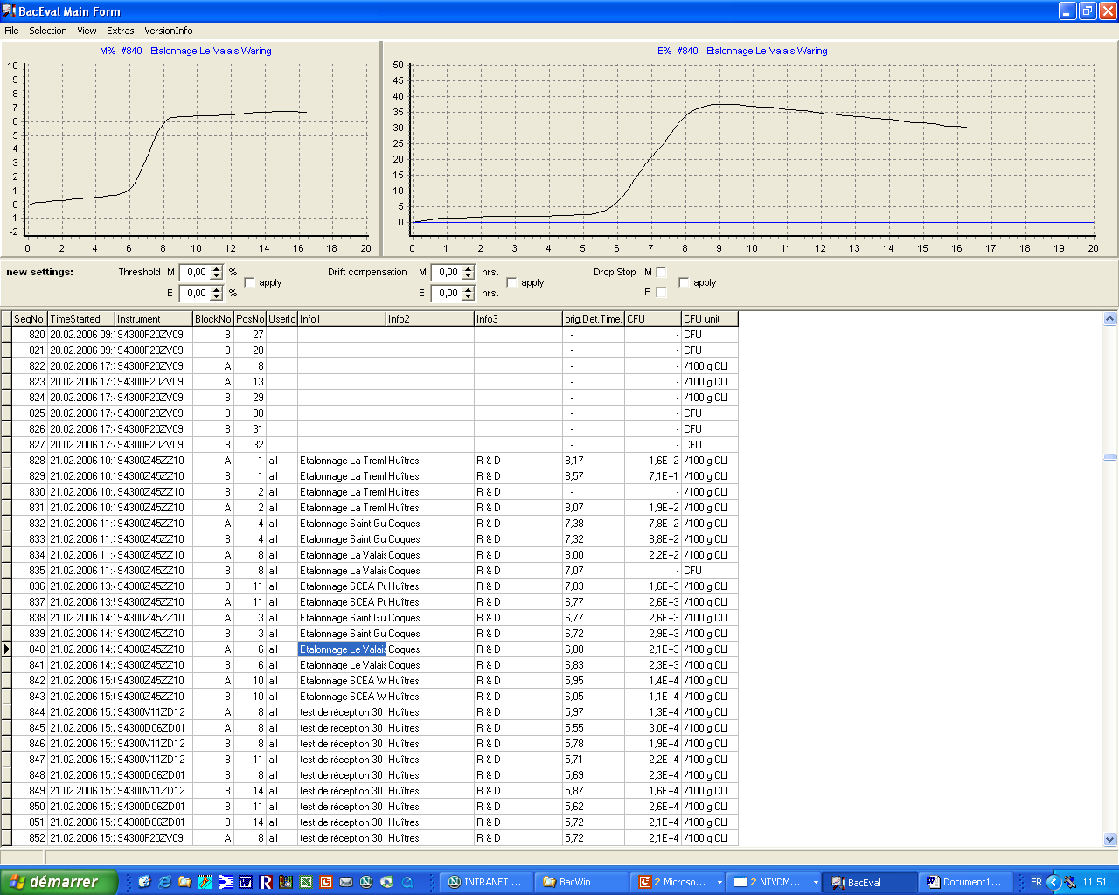
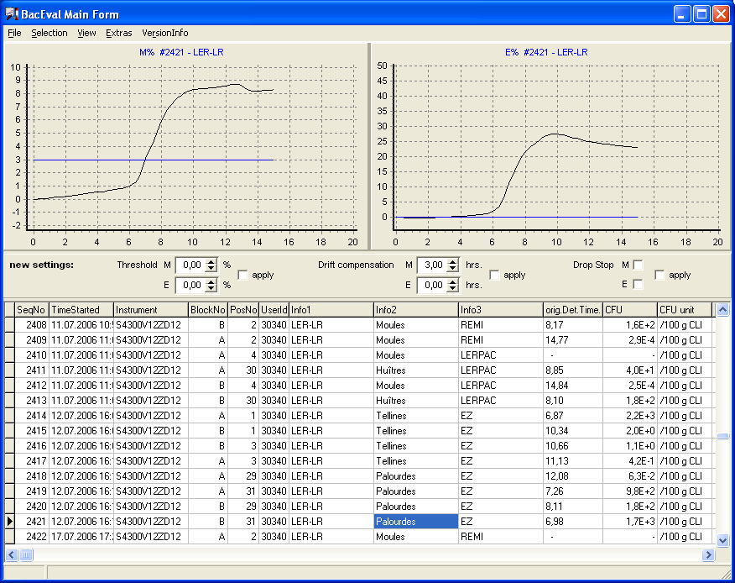
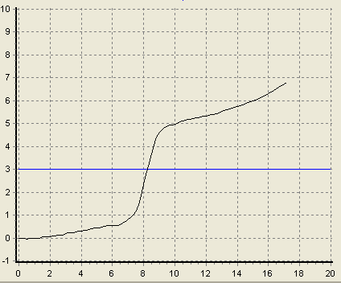
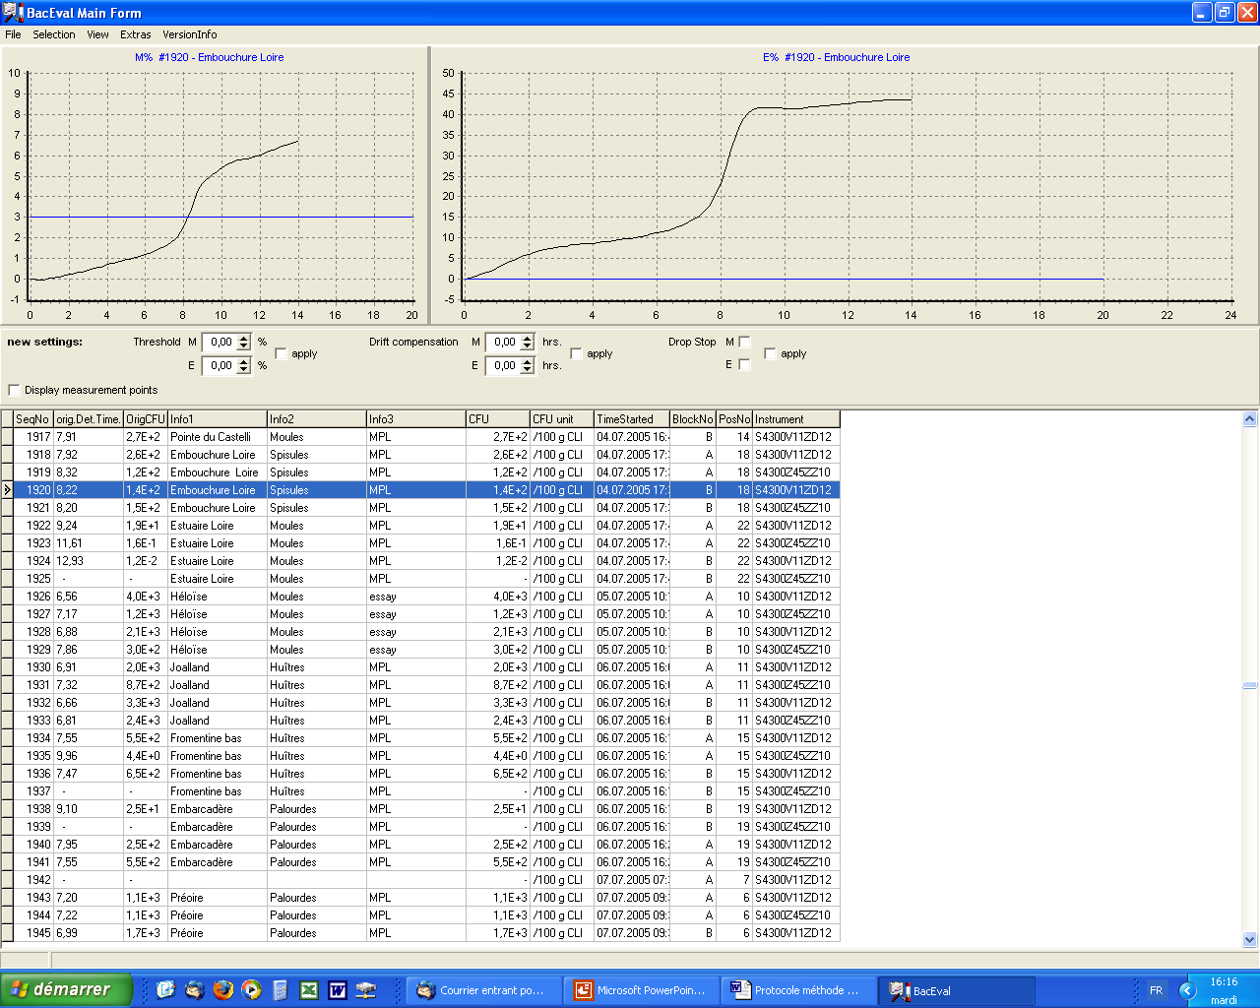
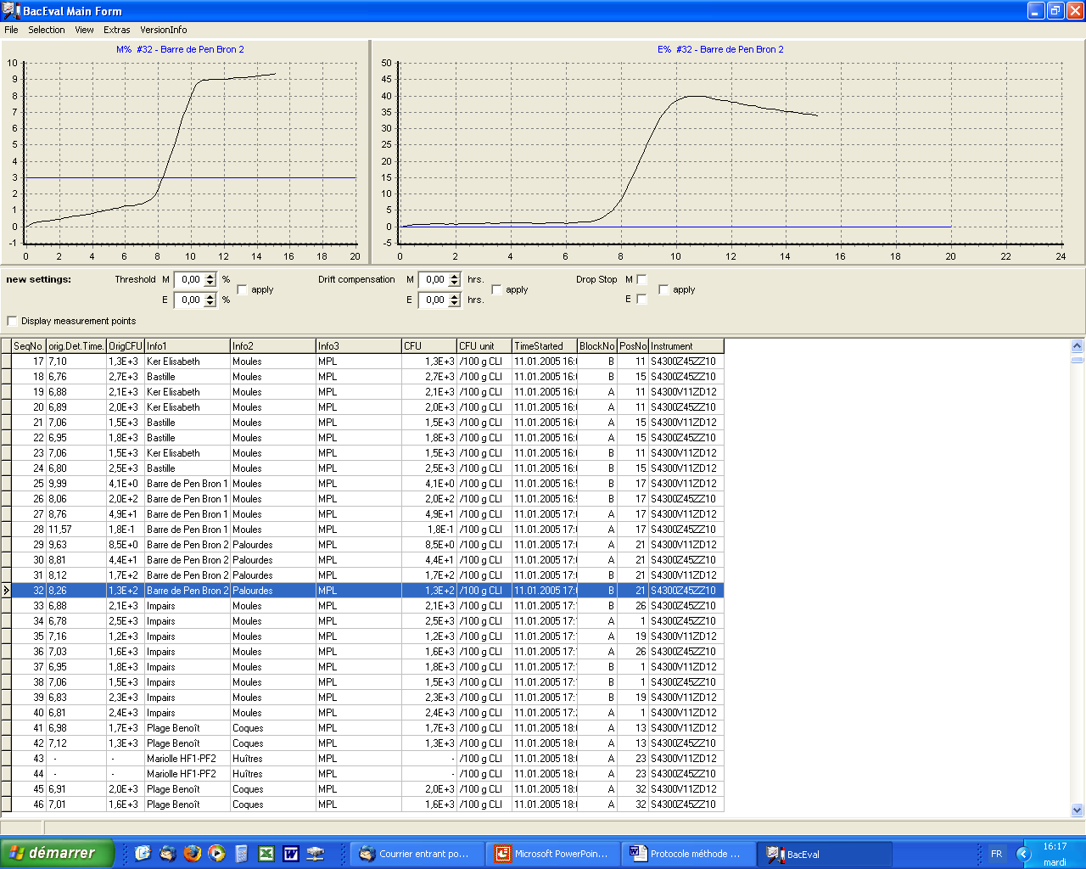
(a)
(b)
(c)
(d)
(e)

Comments: the impedance variation is indicative of the presence of E. coli. The line corresponding to the selected variation threshold (3 %) cuts the curve in its exponential part (the part that falls between the end of the baseline and the start of the plateau).
Conclusion: Retain the result given by BacEval program if it falls between 1.3x10² and 4.0x10⁵ E. coli /100 g FIL.

14.2 Impedance variation non-indicative of the presence of E. coli

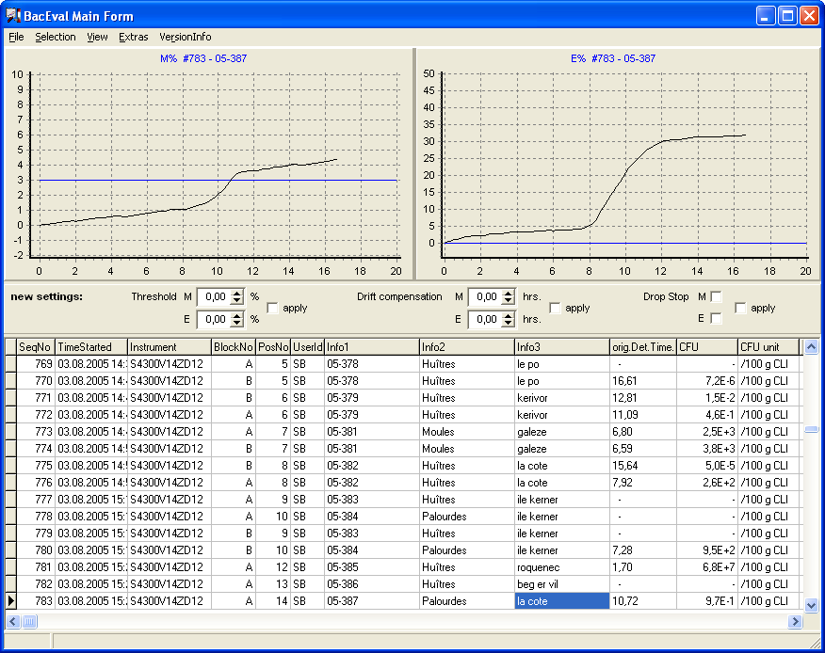
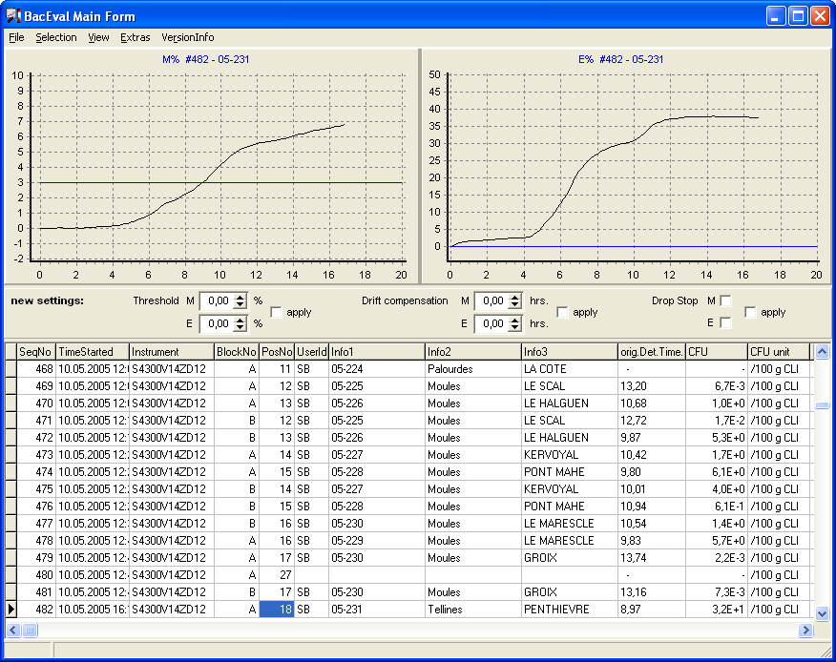
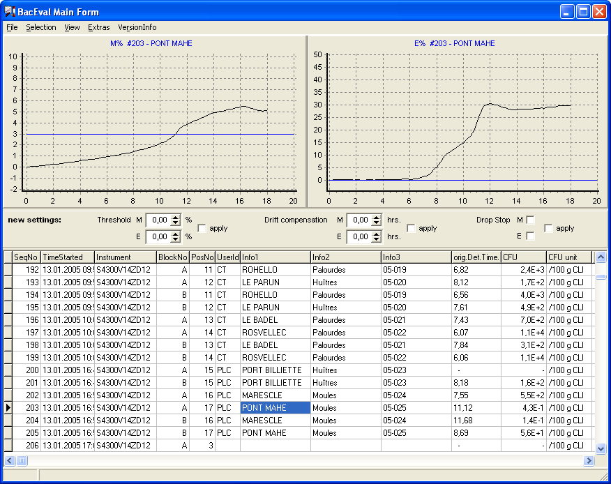
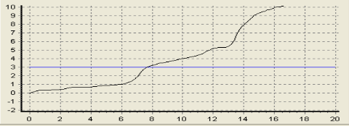
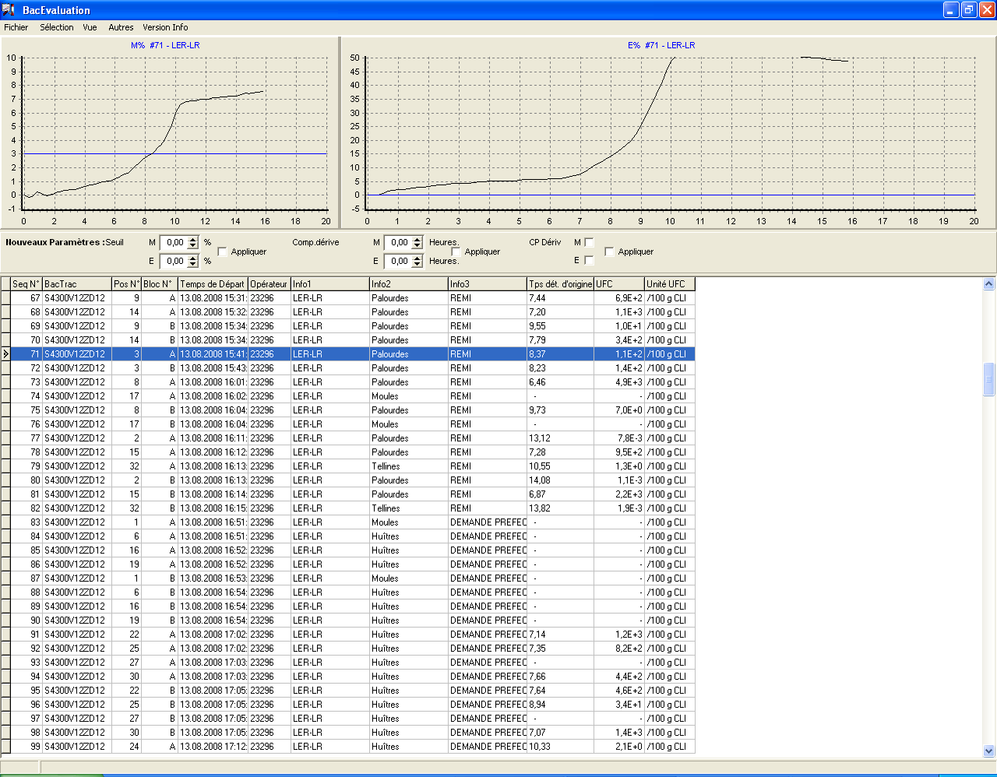
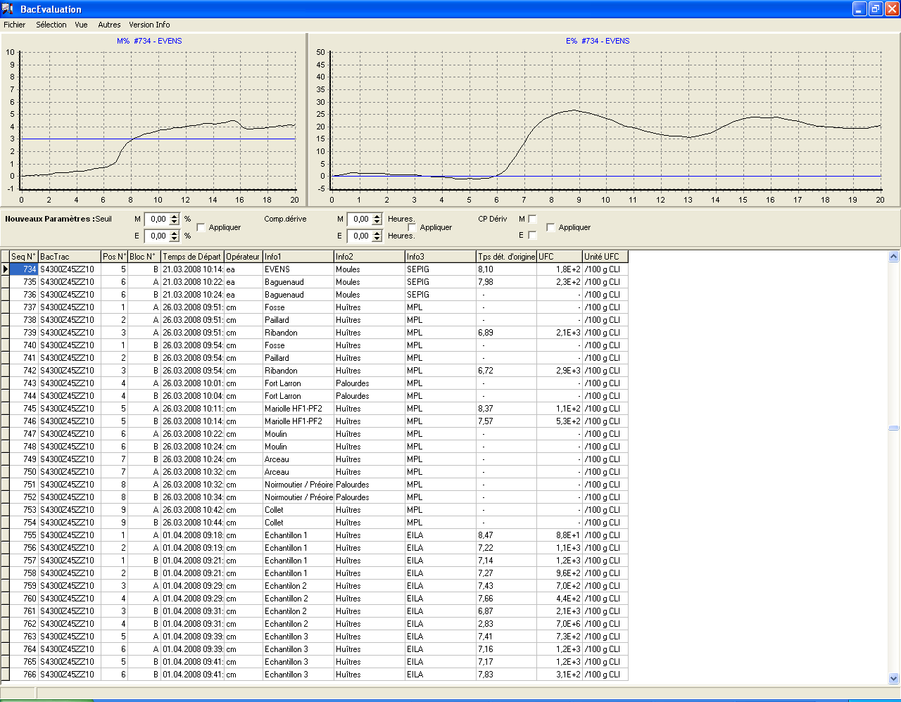
(f)
(g)
(h)
(i)
(k)
(j)

Comments: the impedance variation does not indicate the presence of E. coli because it is not steep enough or too small in its exponential part for curves (f), (g), (h), (i) and (j) or shows a slow change at the start of the exponential phase for curve (k). In addition, the result given by BacEval program for curves (f) and (h) is lower than 1.3x10² E. coli /100 g FIL.
Conclusion: the result is expressed as <1.3x10² E. coli /100 g FIL.

14.3 Absence of impedance variation
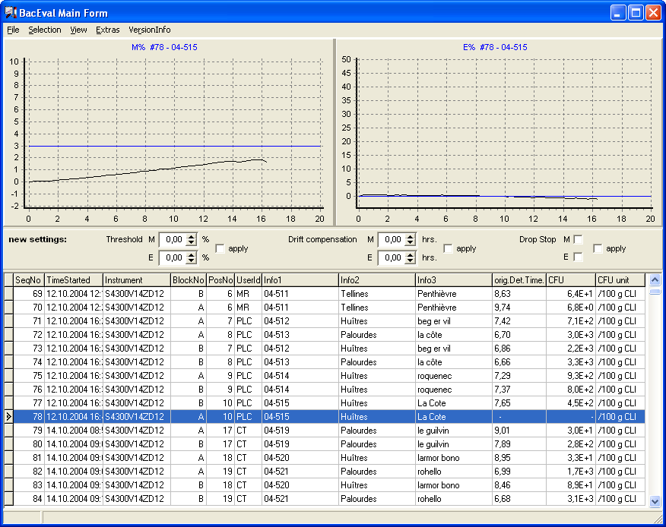
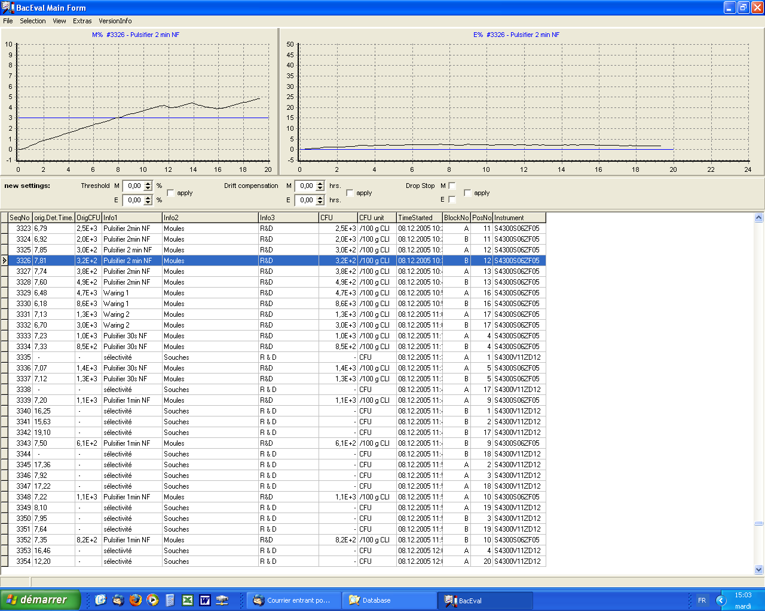
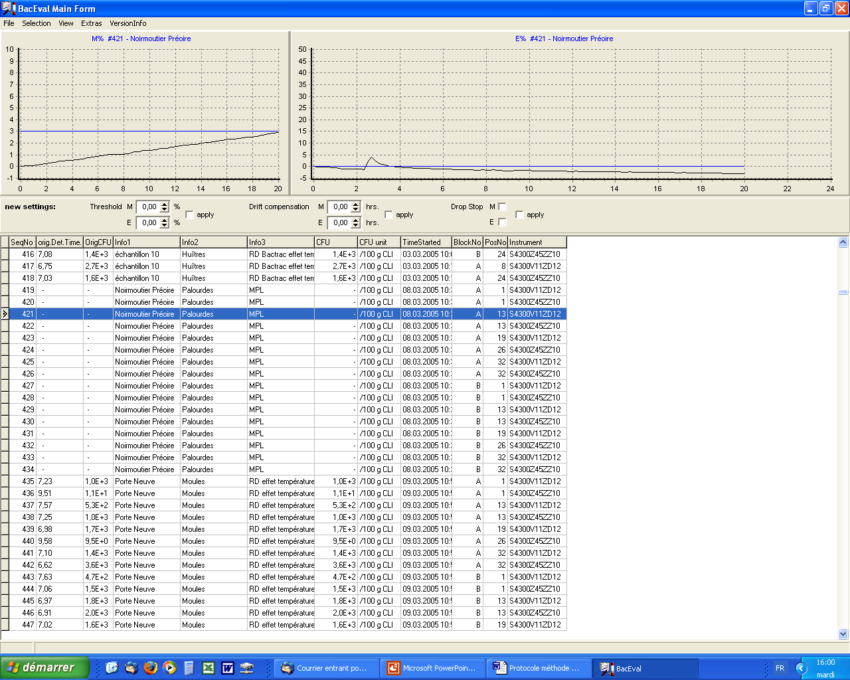
(l)
(m)
(n)

Comments: the increase of impedance is due to a drift of the baseline. The DT for the curve (m) is not valid.
Conclusion: the result is expressed as <1.3x10² E. coli /100 g FIL.

14.4 Non-interpretable impedance variation

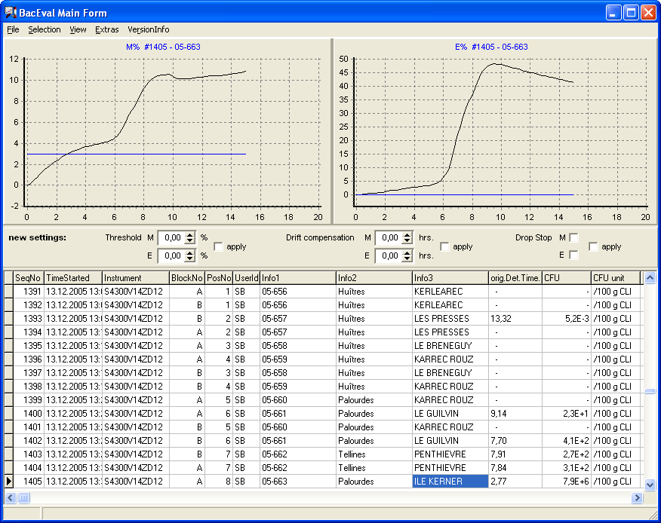
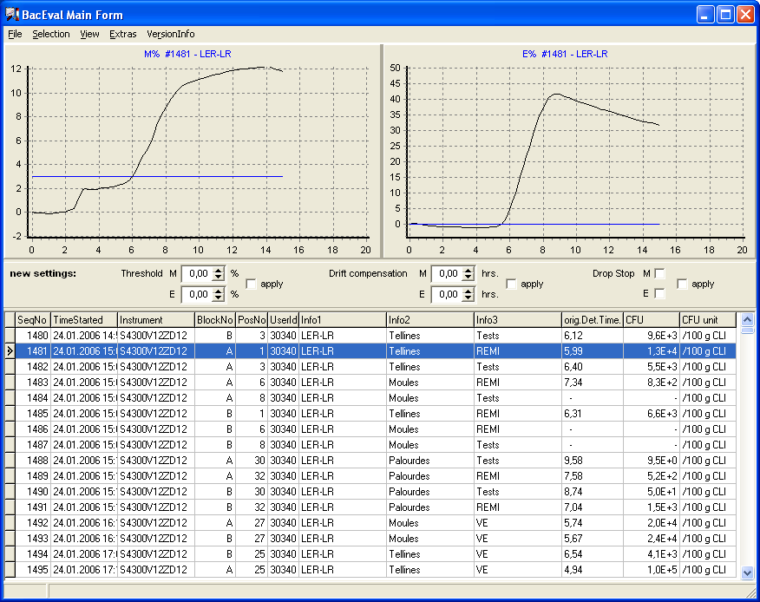
(o)
(p)

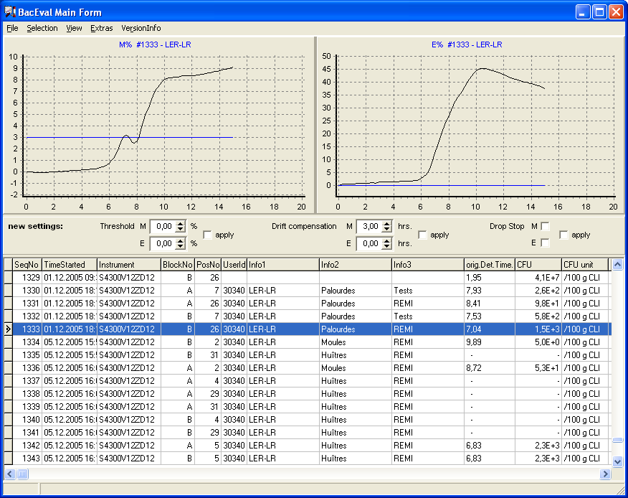
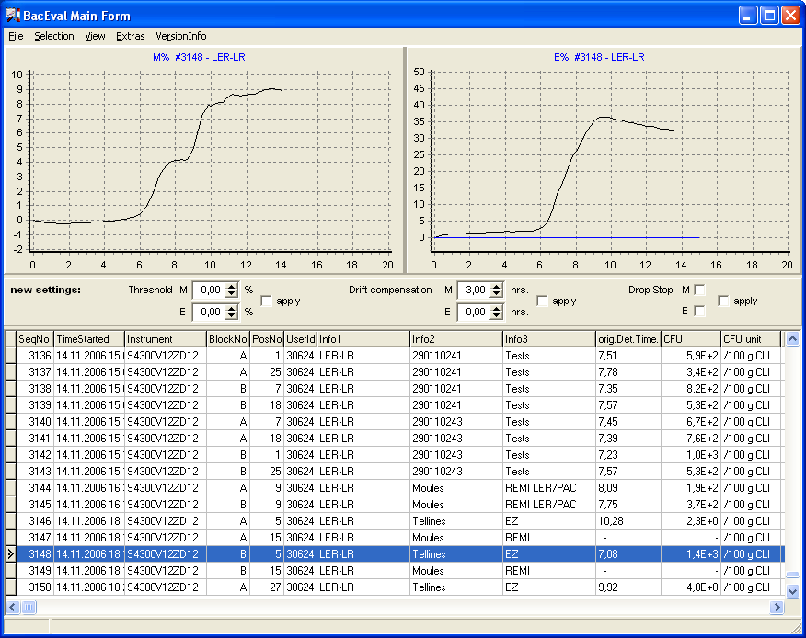
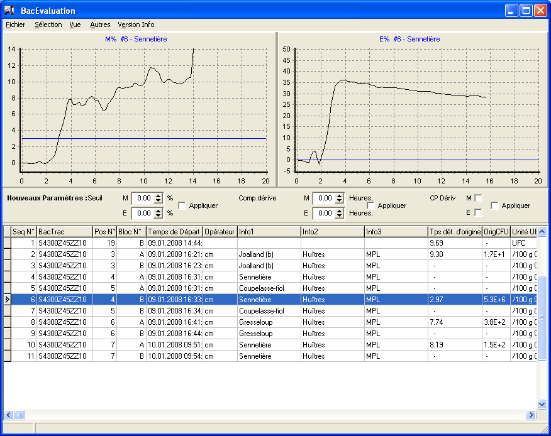
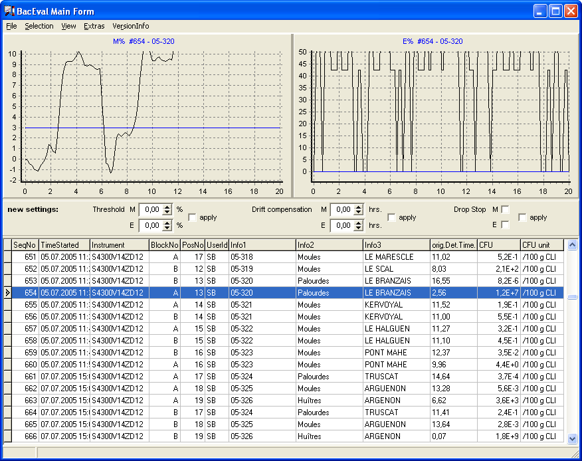
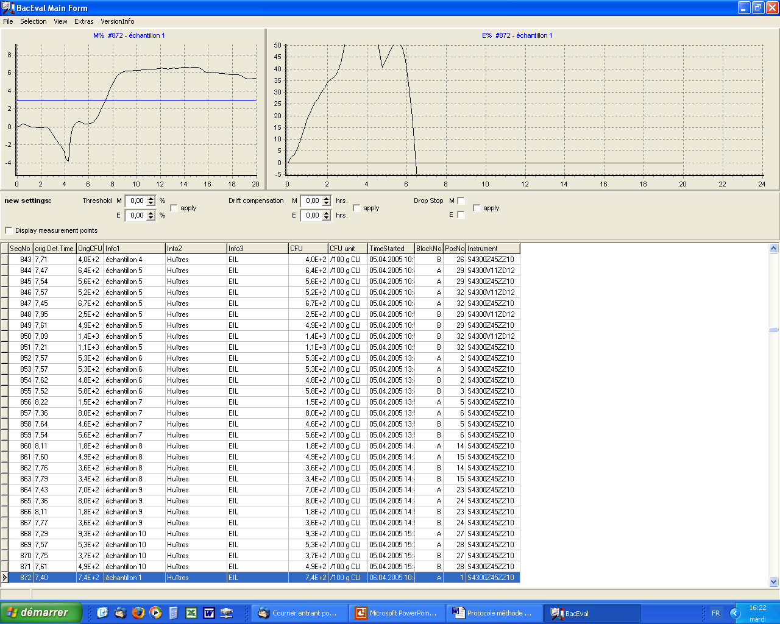
(q)
(r)
(s)
(t)
(u)

Comments: the impedance variation is atypical with a very strong drift of the baseline for curve (o), an impedance jump prior the exponential phase for curve (p) or two exponential phases for curves (q) and (r). Technical problems may cause atypical variation for curves (s), (t) and (u).
Conclusion: the result is considered invalid, and no result is obtained.

